

National Capital Plan – Amendment 87 – Relocation of Indicative Sites for Landmark Buildings (Knowles Place)1

*Australian Capital Territory (Planning and Land Management) Act 1988*

I, FIONA NASH, Minister for Local Government and Territories, approve this amendment of the National Capital Plan under section 19(1)(a) of the *Australian Capital Territory (Planning and Land Management) Act 1988.*

Dated 2 March 2017

FIONA NASH

Minister for Local Government and Territories

1 Name of instrument

This instrument is the *National Capital Plan – Amendment 87 – Relocation of Indicative Sites for Landmark Buildings (Knowles Place)*.

2 Commencement

This instrument commences on the date of its registration.

3 Amendment of National Capital Plan

Schedule 1 amends the National Capital Plan.

Schedule 1 Amendment

(section 3)

***[1] Section 4.6 City Hill Precinct Code***

1. Under the section titled ‘Building height’, delete the second paragraph and replace with:

*Landmark buildings up to RL617 (generally 14 to 18 storeys) will be restricted to the locations identified in Figure 40, generally being the corners of the main avenues intersecting with London Circuit.*

1. Delete Figure 40 and replace with:

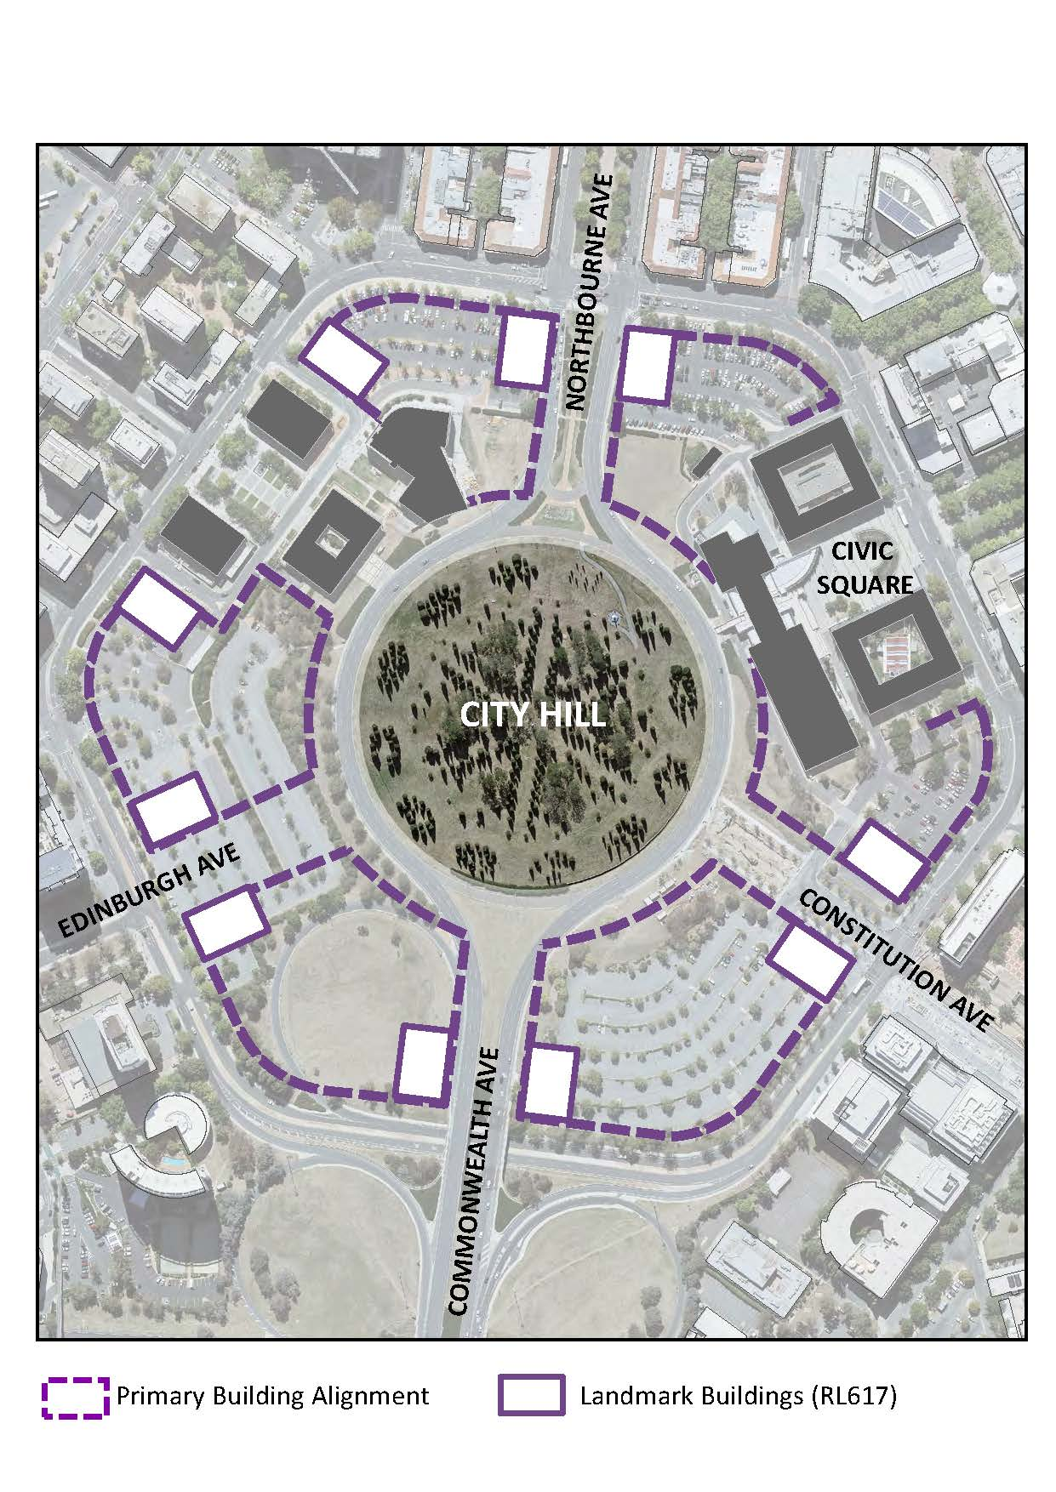

**Note**

1. All legislative instruments and compilations are registered on the Federal Register of Legislation kept under the *Legislation Act 2003*.See http://www.legislation.gov.au.