

National Capital Plan – Amendment 88 – Blocks 3 and 15 Section 22 Barton1

*Australian Capital Territory (Planning and Land Management) Act 1988*

I, DARREN CHESTER, Acting Minister for Local Government and Territories, approve this amendment of the National Capital Plan under section 19(1)(a) of the *Australian Capital Territory (Planning and Land Management) Act 1988.*

Dated 5 December 2017

DARREN CHESTER

Acting Minister for Local Government and Territories

1 Name of instrument

This instrument is the *National Capital Plan – Amendment 88 – Blocks 3 and 15 Section 22 Barton*.

2 Commencement

This instrument commences on the date of its registration.

3 Amendment of National Capital Plan

Schedule 1 amends the National Capital Plan.

Schedule 1 Amendment

(section 3)

## [1] Section 4.4.5, Location Specific

Delete section titled ‘Land use for York Park area’ and replace with:

Development and redevelopment should accord with the detailed conditions of planning, design and development below.

Permitted land uses for the York Park area generally are:

* Diplomatic Mission (with the exception of Blocks 3 and 15 Section 22 Barton)
* National Capital Use
* Office (which may include Commonwealth offices and offices for national associations)
* Open Space.

Permitted ancillary uses are:

* Retail
* Personal Service Establishment
* Child Care Centre.

Additional permitted land uses for Blocks 3 and 15 Section 22 Barton are:

* Commercial Accommodation (not including a caravan park/camping ground)
* Residential
* Additional permitted ancillary land uses for Blocks 3 and 15 Section 22 Barton are:
  + Cafés
  + Restaurants.

Commercial parking structures in the York Park area are to be located where identified on the Indicative Development Plan at Figure 17. Retail and Personal Service Establishments are permitted at the ground level of parking structures as ancillary small scale facilities.

Retail and Personal Service Establishments should be provided at the ground floor level of Offices and structured Car Parks in the location identified for a ‘Retail Plaza’ on the Indicative Development Plans at Figure 17 and Figure 20.

Large spaces for recreation are to be provided at either end of Windsor Walk including a large space suitable for active recreation at the Canberra Avenue end of Windsor Walk as depicted in Figure 17.

## [2] Figure 17: York Park Masterplan – Indicative development plan

Delete Figure 17 and replace with:

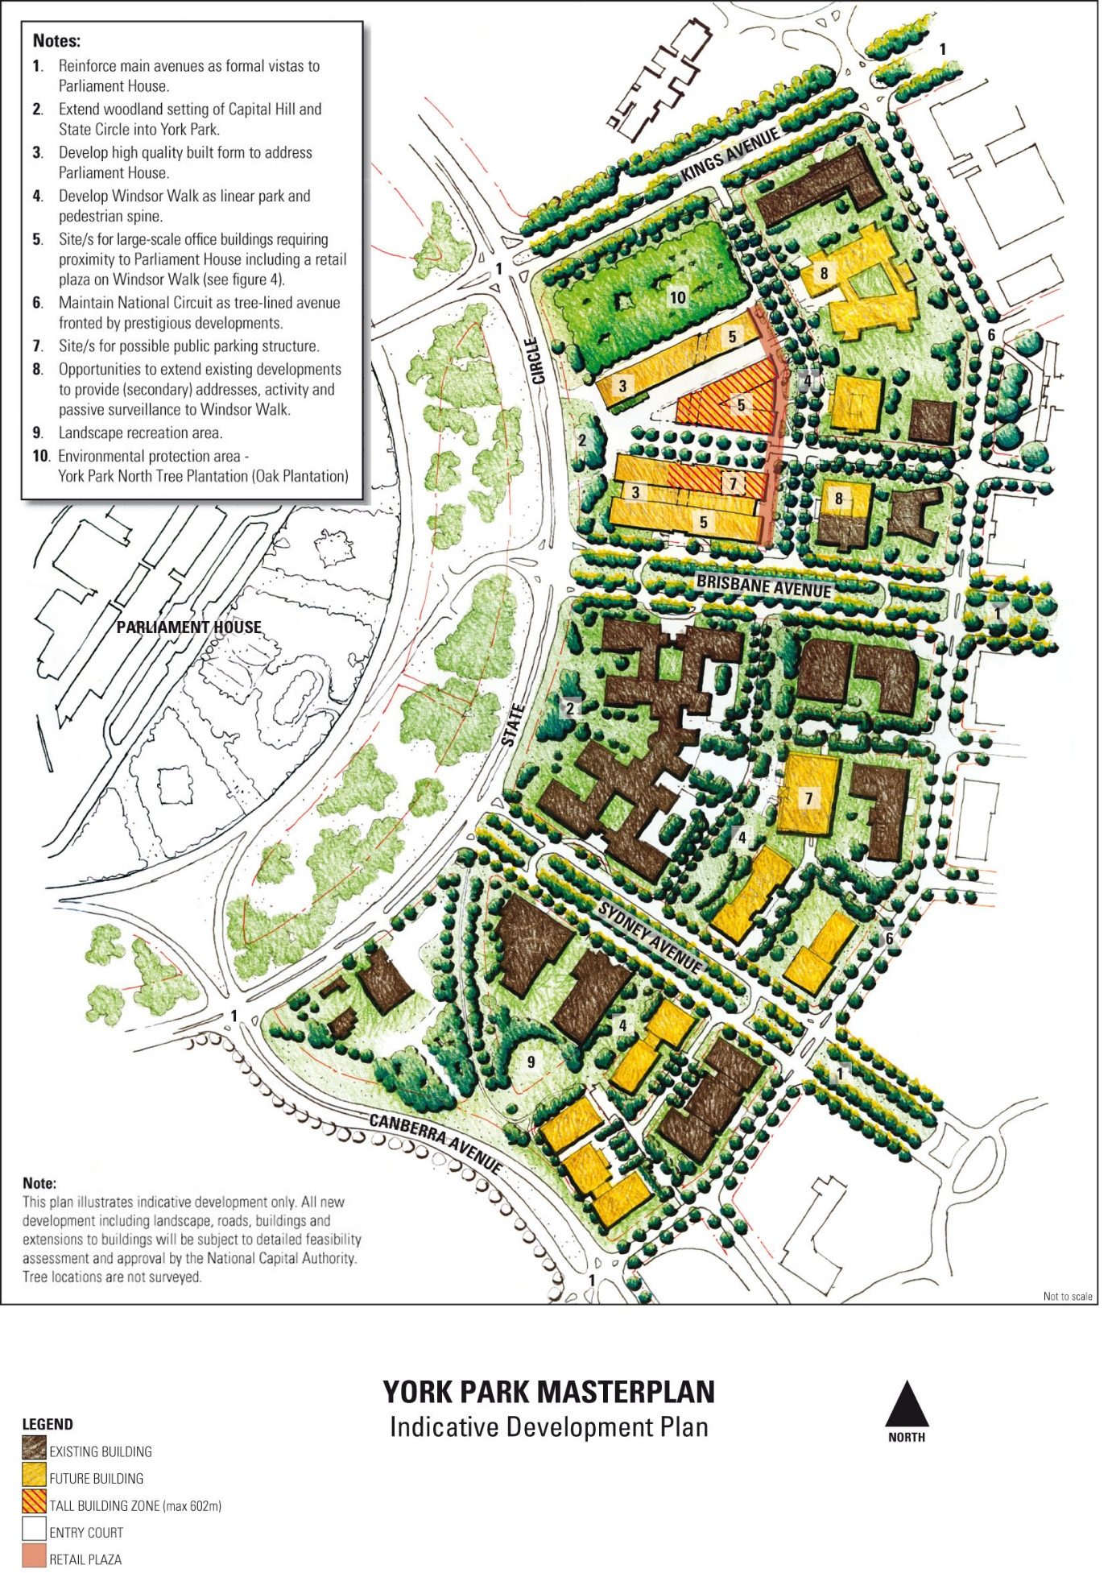

## [3] Section 4.4.5, Other sites

Delete section titled ‘Block 3 Section 22 Barton’.

**Note**

1. All legislative instruments and compilations are registered on the Federal Register of Legislation kept under the *Legislation Act 2003*.See http://www.legislation.gov.au.