

National Capital Plan – Amendment 94 – National Arboretum Commercial Accommodation1

*Australian Capital Territory (Planning and Land Management) Act 1988*

I, NOLA MARINO, Assistant Minister for Regional Development and Territories, approve this amendment of the National Capital Plan under section 19(1)(a) of the *Australian Capital Territory (Planning and Land Management) Act 1988.*

Dated 1 May 2020

NOLA MARINO

Assistant Minister for Regional Development and Territories

1 Name of instrument

This instrument is the *National Capital Plan – Amendment 94 – National Arboretum Commercial Accommodation*.

2 Commencement

This instrument commences on the date of its registration.

3 Amendment of National Capital Plan

Schedule 1 amends the National Capital Plan.

Schedule 1 Amendment

(section 3)

The National Capital Plan is amended by the following:

1. Under section 3.2.4.4, add the following to the range of permitted uses in the Hills, Ridges and Buffers Spaces part of the National Capital Open Space System (NCOSS):

* Commercial Accommodation, not including a motel, guest house, caravan park/camping ground, serviced apartment, serviced house (Forest 69 and 76, National Arboretum - only)
* Personal Services Establishment (Forest 76, National Arboretum only)

1. Add a new section 3.2.4.4 titled ‘Detailed conditions of planning, design and development – Commercial Accommodation at the National Arboretum Canberra’ as follows:

## General principles and policies

1. Built form must sit within the landscape setting of the Inner Hills, with the landscape to remain the dominant feature.
2. Buildings and landscape must exhibit design excellence in recognition of the site’s visual prominence from the Central National Area, Governor-General’s residence, and its location within the Inner Hills.
3. Buildings must explicitly adopt a similar materials palette to existing buildings at the arboretum so as to create an identifiable family of arboretum buildings.
4. Landscaping must be complementary to the existing and intended design themes of the arboretum.

## Location

Commercial Accommodation is restricted to Forests 69 and 76 of the National Arboretum Canberra, as identified in Figure 8. Personal Service Establishment is restricted to Forest 76 of the National Arboretum Canberra.

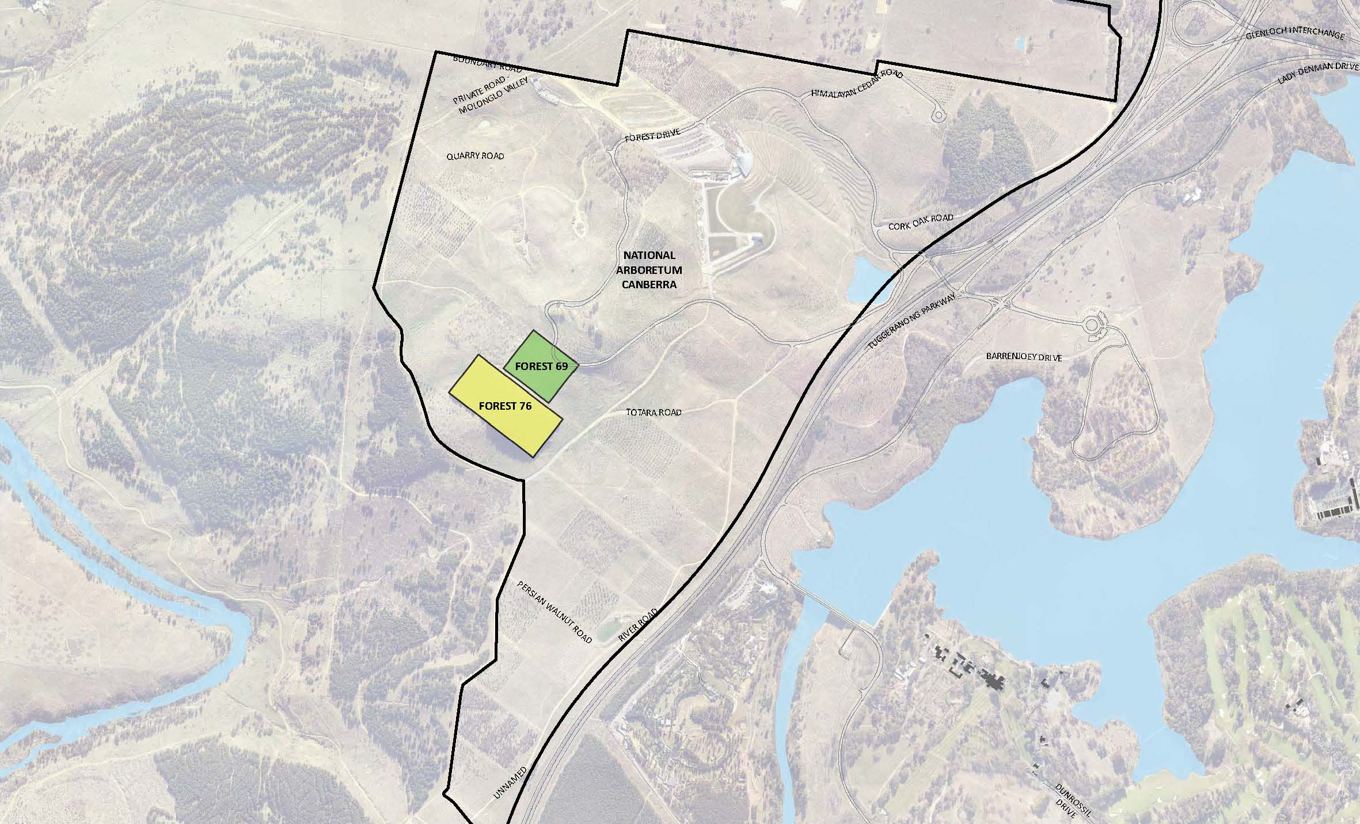

Figure 8: Permitted location of commercial accommodation at the National Arboretum Canberra (Forests 69 and 76)

## Built form

Buildings on the eastern slope of Forest 69 must be no more than a single storey or seven metres above datum ground level in height. Buildings on the western slope of Forest 69 must be no more than two storeys in height and must not exceed the maximum RL of the top of any building located on the eastern slope. Buildings on the southern slope of the site, within Forest 76, must be no more than seven metres above datum ground level in height and two storeys.The maximum height of seven metres is to be measured at the intersection of the highest point of built form with the natural ground level.

Buildings must be designed and sited to be visually recessive and sit within the landscape when viewed from the Central National Area. Built form should consist of a series of buildings within a generous landscape and forest setting. The materials palette for new buildings must explicitly adopt similar materials to those used for existing buildings at the arboretum.

A visual analysis must be undertaken to demonstrate the impact of development from the Central National Area and key vantage points such as Lake Burley Griffin, the Governor-General’s residence, and Parliament House.

Service areas and facilities such as loading zones, water tanks, waste enclosures must be incorporated into the building form.

Requirements for built form, and design and siting of development are shown in Figure 9.

Figure 9: Site layout and built form requirements for commercial accommodation at the National Arboretum Canberra (Forests 69 and 76)

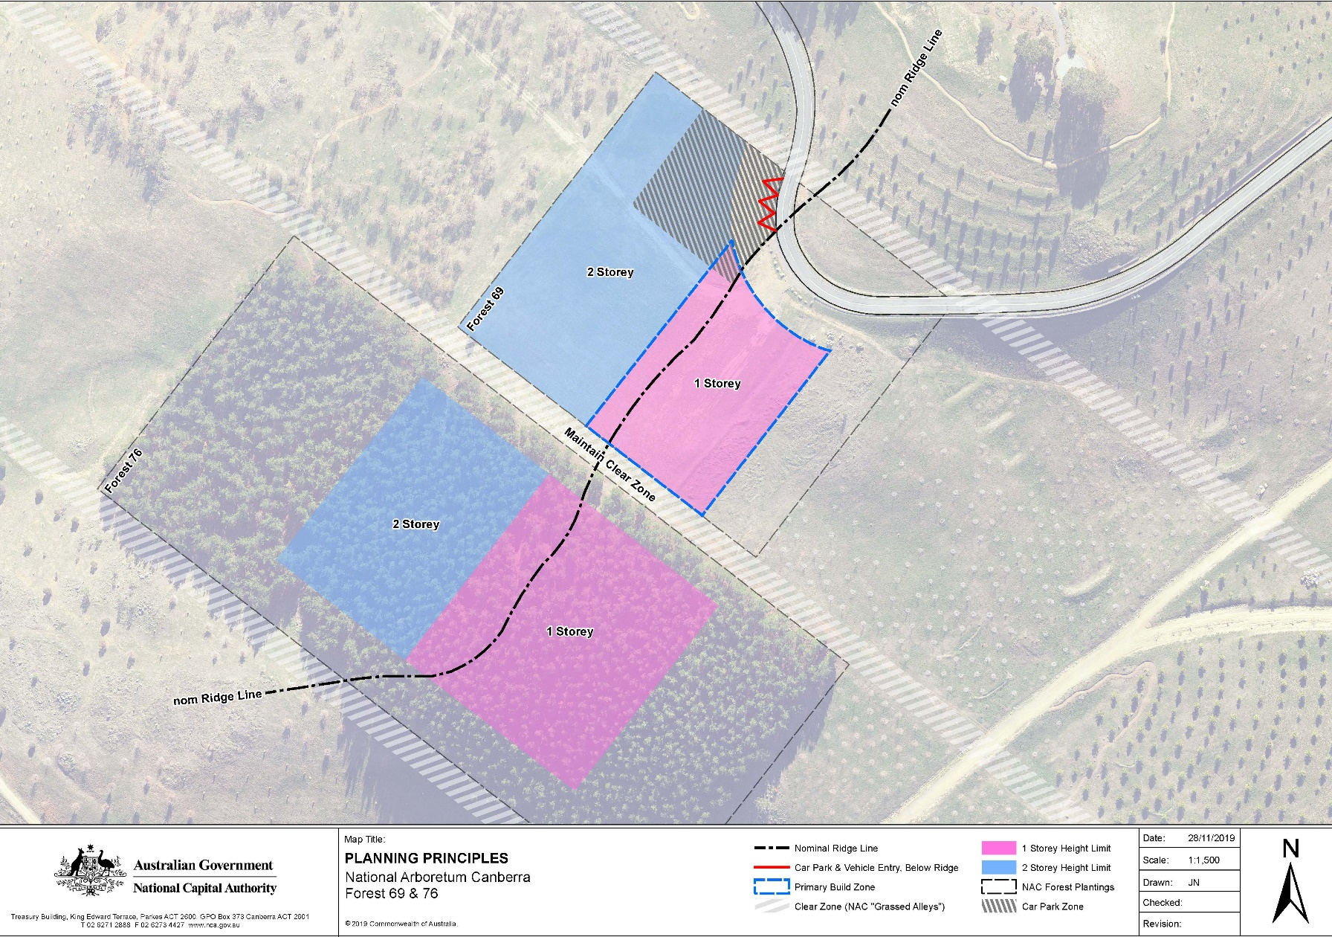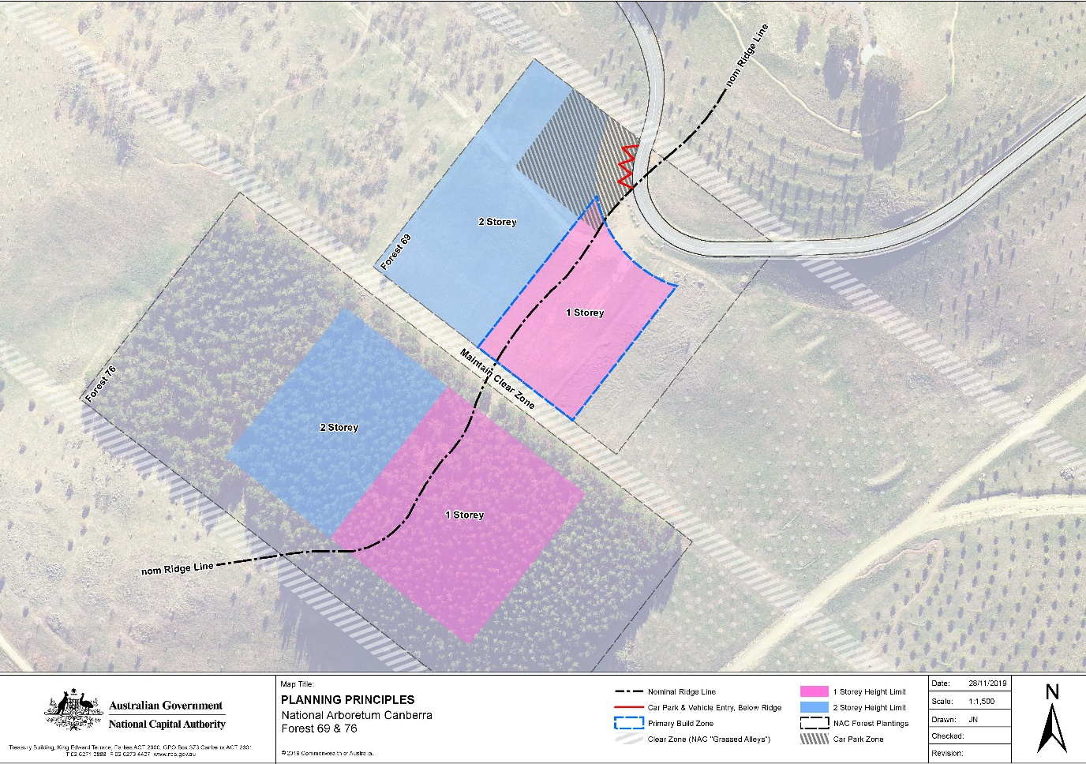

## Design and siting

Development must demonstrate excellence in architecture, landscape architecture and urban design, including through the use of high quality and durable materials.

The total footprint of all buildings must not occupy more than ten per cent of the total site area of Forests 69 and 76.

A maximum of 40 guest rooms is permitted. Guest rooms are not permitted in the single storey precinct of Forrest 69.

Additional amenities such as a restaurant and supporting back of house facilities are permitted within the hotel where it can be demonstrated that they are necessary for the successful operation of the hotel.

Development should achieve best practice in environmentally sustainable design through the use of innovative technology, design and ongoing building operation. Development should be designed to:

* reduce energy consumption, reduce total operating greenhouse gas emissions, and reduce peak demand through particular design measures such as appropriate building orientation, space allocation for solar panels, and shading to glazed surfaces
* improve water efficiency, reduce total operating potable water use, collect and reuse stormwater, use alternative water sources (such as greywater)
* provide a healthy indoor environment including the provisions of fresh air, cross ventilation and natural daylight, reduce reliance on mechanical heating, ventilation, lighting and cooling
* minimise noise levels and noise transfer within and between buildings and associated external areas
* incorporate the use of water sensitive urban design, including stormwater collection and reuse.

Building and landscape design should incorporate biophilic design patterns that enhance connectivity with nature, and contribute to the health and well-being of visitors. Examples of how this may be achieved include:

* using the site’s location within the arboretum to create opportunities for direct visual connections to nature, living systems and natural processes
* designing buildings that allow natural fluctuations in temperature, airflow, and humidity to mimic natural environments
* providing opportunities to experience the place through the seeing, hearing or touching of water
* the use of biomorphic forms and patterns in building materials and landscape design, including contoured, patterned, textured or numerical arrangements that persist in nature
* landscape design that entices people to travel deeper into the environment
* the use of materials or landscape elements from nature that, through minimal processing, reflect the local ecology or geology and create a distinct sense of place.

Building and landscape design must consider the privacy and security of guests. Fencing is not permitted. Landscape should be used to delineate between the public and private realms.

Buildings should be sited to take advantage of views and vistas to the Brindabella Ranges to the west and north-west, and to the Central National Area in the east.

Development must demonstrate consideration of climatic conditions, including wind and heat. Proposals must also demonstrate consideration of resilience to extreme weather events, such as bushfire, and the measures proposed to manage the impacts from such events.

Development proposals must incorporate measures to address noise generated from external sources, including from the Tuggeranong Parkway. Measures may include the use of building materials to reduce noise levels in building interiors, the use of landscape, and the siting and orientation of the residential components away from noise sources.

## Landscape

Soft landscaping around buildings should incorporate a range of planting types of varying scales, including trees, shrubs and ground-covers to create a rich, diverse garden setting.

Buildings and landscape design must reflect the original design intent of the arboretum masterplan. Tree plantings should act as an extension of the planted forests of the arboretum. Within Forest 69, tree plantings must predominantly be Chinese Golden Larch. New tree plantings within Forest 76 must predominantly be Radiata Pine.

As far as practicable, Radiata Pine plantings in Forest 76 should be retained to protect the site from southerly winds. New tree plantings and landscape design should afford protection from other predominant winds.

Landscape design should ensure that when trees are mature, development of the site does not significantly detract from the view from Dairy Farmer’s Hill.

Planting on buildings and structures is encouraged as a way of enhancing the integration between built form and landscape, and to provide amenity, improve air quality and microclimate, and reduce direct energy use and stormwater runoff. Where planting on buildings and structures is proposed, landscape materials should respond to local context and complement arboretum species.

## Access, parking, and movement

Primary vehicle access to the site is to be from Forest Drive. Secondary access, including for emergency vehicles, must be provided and agreed by the relevant authorities.

Car parking must be screened from view to the maximum extent possible from Forest Drive, Dairy Farmers Hill, and the Central National Area. Parking provision shall be in accordance with the following:

* 1 space per guest room, plus
* 10 spaces per 100m2 GFA of bars, restaurant, function rooms and supporting back of house facilities, plus
* 3 spaces per 5 employees

Basement car parking is encouraged to increase the site area that can be landscaped, and to reduce light spill. Where surface car parking is proposed, parking must be incorporated into the landscape design of the site, by extending planting and materials into car parking spaces. Parking must be located on the western side of the ridge. Shade trees should be planted between every 4 car parking spaces to reduce increased surface temperatures from large areas of paving.

Access arrangements must demonstrate consideration of increased traffic on Forest Road as visitation to the National Arboretum Canberra increases, and the role of Forest Drive as a designated cycling route. The design of access arrangements should be designed to ensure pedestrian and cycle priority, and that conflict between vehicles, and cyclists and pedestrians, is minimised.

Path networks across the site must:

* Accommodate the needs of people with a wide range of abilities, including:
  + ensuring that access arrangements and public spaces are appealing for all users, and avoids segregating or stigmatizing any users
  + providing equitable privacy, security and safety for all users
  + minimizing hazards and the adverse consequences of accidental or unintended actions.
  + demonstrate consideration of existing recreation trails and how these integrate with new facilities and infrastructure.
* Provide a visually engaging experience, for example through landscape design and public art.
* Be of sufficient width to accommodate all intended users, including pedestrians and vehicles associated with the movement of people and goods between commercial accommodation facilities. Where possible, separate path networks should be constructed to improve safety and amenity.

## Signage

A cohesive and co-ordinated signage suite must be developed that:

* responds to the scale, proportion and detailing of the development
* utilises wayfinding markers, both integrated with the built form and within the landscape to identify destinations and points of reference
* includes parking and other regulatory signage integrated with the public realm design and complementary to signage used throughout the arboretum

Illuminated signage must not be visible from the Central National Area.

No animated or flashing signage is permitted.

## Lighting

All outdoor lighting, including security and car park lighting, must be designed and sited to minimise light pollution. Lighting solutions must carefully consider any impact on Mount Stromlo Observatory, and views to the site from the Central National Area.

All outdoor lighting (including lighting fixed to structures) must use full cut-off light fittings. Any up-lighting of buildings should be carefully designed to keep night time overspill and glare to a minimum.

1. Recognise consequential changes to page numbers, figure numbers and text references, and contents page.

**Note**

1. All legislative instruments and compilations are registered on the Federal Register of Legislative Instruments kept under the *Legislation Instruments Act 2003*.See http://www.legislation.gov.au.