

*Australian Capital Territory (Planning and Land Management) Act 1988*

Draft Amendment 91

City and Gateway Urban Design Provisions

January 2019

# Introduction

The National Capital Authority (NCA) is established under the *Australian Capital Territory (Planning and Land Management) Act 1988* (the Act). The National Capital Plan (the Plan) came into effect on 21 January 1990. In accordance with the Act, the NCA is required to keep the Plan under constant review and to propose amendments to it where necessary. The object of the Plan is *‘to ensure that Canberra and the Territory are planned and developed in accordance with their national significance’*.

The Plan identifies matters of national significance in the planning and development of Canberra and the Territory. These are:

* The pre-eminence of the role of Canberra and the Territory as the centre of National Capital functions, and as the symbol of Australian national life and values.
* Conservation and enhancement of the landscape features which give the National Capital its character and setting, and which contribute to the integration of natural and urban environments.
* Respect for the key elements of the Griffins’ formally adopted plan for Canberra.
* Creation, conservation and enhancement of fitting sites, approaches and backdrops for national institutions and ceremonies as well as National Capital uses.
* The development of a city which both respects environmental values and reflects national concerns with the sustainability of Australia’s urban areas.

Within the framework of this legislative object or goal, key objectives of the Plan are to:

* Recognise the pre-eminence of the role of Canberra and the Territory as Australia’s National Capital.
* Further develop and enhance the Central National Area which includes the Parliamentary Zone and its setting and the main diplomatic sites and national institutions, as the heart of the National Capital.
* Emphasise the national significance of the main avenues and approach routes.
* Respect the geometry and intent of Walter Burley Griffin’s formally adopted plan for Canberra.
* Maintain and enhance the landscape character of Canberra and the Territory as the setting for the National Capital.
* Protect the undeveloped hill tops and the open spaces which divide and give form to Canberra’s urban area.
* Provide a plan offering flexibility and choice to enable the Territory government properly to fulfil its functions.
* Support and promote environmentally responsible urban development practices.

The purpose of Draft Amendment 91 – City and Gateway Urban Design Provisions (DA91) is to implement the NCA’s interest in the City and Gateway Urban Design Framework by establishing detailed planning and design criteria for development on land flanking the Federal Highway and Northbourne Avenue.

DA91 to the Plan (set out in Part 2: National Capital Plan Draft Amendment 91 – City and Gateway Urban Design Provisions) has been prepared in accordance with section 23 of the Act.

# Part 1: Context

## Background

The Australian Government through the NCA, and the ACT Government, share planning responsibility in the ACT. The mutual interest and responsibility in the city and gateway corridor, including the Federal Highway, Northbourne Avenue, and the city centre, prompted the need for a revised planning and design framework to guide future design and development.

The Federal Highway and Northbourne Avenue corridor forms a key approach to Canberra’s city centre. The NCA’s interest lies in ensuring that the corridor reflects the significance of Canberra as the National Capital and the high development and landscaping standards are observed along the length of the corridor.

In March 2018, the NCA and ACT Government’s Environment, Planning and Sustainable Development Directorate (EPSDD) released the City and Gateway Draft Urban Design Framework for public consultation. The draft framework was developed collaboratively between the NCA and EPSDD to set the principles for development and growth in the city centre and along the gateway corridor of Northbourne Avenue and the Federal Highway.

The draft framework was amended in response to community comment, and was subsequently endorsed by the NCA and ACT Government. The final City and Gateway Urban Design Framework (City and Gateway Framework) is available on the NCA’s website at [www.nca.gov.au](http://www.nca.gov.au).

The City and Gateway Framework reflects the interests and expectations of both governments in a single urban design document. The Framework sets out the overarching principles for urban renewal and growth in the city centre and along the corridor to achieve well-designed and sustainable buildings, urban infrastructure, public places and streets that is appropriate for the gateway to the National Capital.

In addition to DA91, the ACT Government’s Environment, Planning and Sustainable Development Directorate will undertake the process to vary the Territory Plan. The variation will reflect the Territory’s interest in the City Centre and gateway corridor.

## The City and Gateway Corridor

The area subject to the Framework includes the city centre and the linear corridor roughly one kilometre east and west of Northbourne Avenue, extending from Lake Burley Griffin to the Federal Highway and its intersection with the ACT border. Principles of the Framework concerned with transport and movement take into account the broader metropolitan context of north Canberra, including the peripheral arterial network of Gungahlin Drive and Majura Parkway.

Areas where the NCA has a direct or high level of interest relate to only a portion of the area subject to the Framework. It includes the Australian National University (ANU), City Centre, Haig Park, the road reservations of the Federal Highway, Barton Highway and Northbourne Avenue, and land flanking these roads.

DA91 specifically relates to the land flanking the Main Avenue of Northbourne Avenue and the Federal Highway Approach Route (refer Figure 1), and reflects the NCA’s interest in these roads. The Plan already contains policy for other areas of NCA interest within the area subject to the Framework (for example, ANU, City Hill, and West Basin). The NCA considers the policy for these areas is robust and it is not proposed to change these policies at this time.

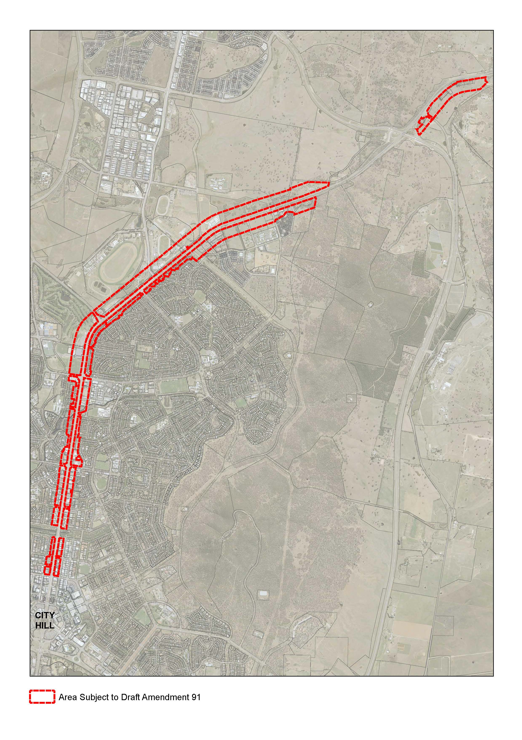

Figure 1: Area subject to Draft Amendment 91 – City and Gateway Urban Design Provisions

## 1.3 Explanatory statement

The Framework sets a vision for the city and gateway corridor, supported by a series of strategic goals, principles and design criteria. Implementation of the Framework’s goals, principles and design criteria requires (in part) changes to planning controls along the corridor. An amendment to the Plan is required to give effect to the City and Gateway Framework.

### Existing planning arrangements

Section 10 of the *Australian Capital Territory (Planning and Land Management) Act 1988* (the Act) states that the Plan *‘may set out special requirements for the development of any area (not being a Designated Area), being requirements that are desirable in the interests of the National Capital*’. Special Requirements are typically established for areas where the location is such that it contributes to the appreciation of the character of the National Capital.

The majority of land adjacent to Northbourne Avenue and the Federal Highway is currently subject to Special Requirements under the Plan. For Northbourne Avenue, principles and policies sit within the Plan. These policies guide building height, setbacks, and landscape character.

For the Federal Highway, the Plan currently requires that Development Control Plans (DCPs) be prepared to guide development. A number of DCPs currently apply to land adjacent to the Federal Highway, primarily on a site-by-site basis. The DCPs address a range of matters such as building height and setbacks, building design (including materials and colours), landscape, access and car parking, signage, and fencing.

Where Special Requirements apply along the Federal Highway and Northbourne Avenue corridor, the Territory planning authority in compliance with the Special Requirements administers any development proposal.

### Proposed planning arrangements

Special Requirements will be retained for both the Federal Highway and Northbourne Avenue. DA91 proposes to remove the need for DCPs to guide development on land fronting the Federal Highway, and instead include planning and design policy within the Plan itself. This replicates the existing arrangement for Northbourne Avenue.

### Proposed policy

Policy proposed by DA91 is intended to:

1. Create an identifiable approach, which increases in formality as it gets closer to the city centre and Central National Area, and which clearly signifies the symbolic and functional roles of the National Capital.
2. Encourage a design-led approach to development with a focus on high quality interfaces between built form and urban landscapes.
3. Ensure that buildings and landscape exhibit design excellence in recognition of the corridor’s role as a key northern approach route to the city.
4. Create a landscape setting, including deep root plantings, to provide amenity, assist with climate control, and create comfort for pedestrians.
5. Encourage sustainability as a base requirement for all new buildings.

These overarching objectives will be supported by more detailed policy to guide such matters as building envelope (heights and setbacks), landscape character, building design and architecture, residential unit design, the relationship between buildings and the street, and site access.

## Effect of the draft amendment

DA91 will have the following effect:

1. Introduce policy to guide the development of buildings and landscape that exhibit design excellence.
2. Remove the need for Development Control Plans (DCPs) to be prepared to guide development on land fronting the Federal Highway.
3. Maintain the application of Special Requirements for both Northbourne Avenue and the Federal Highway, however contain all policy within the Plan rather than DCPs.
4. Continue current arrangements whereby the Territory planning authority administers Special Requirements through the Development Assessment process.
5. Result in existing DCPs for sites adjacent to the Federal Highway ceasing to have effect.
6. Introduce additional definitions to the Plan to assist with the interpretation of policy.

## 1.5 Draft Amendment process

The process for making an amendment to the Plan is outlined in Figure 2.

Figure 2: Outline of the National Capital Plan draft amendment process

|  |
| --- |
| **WHAT HAS BEEN DONE** |
| Proposal by the NCA of a Draft Amendment to the Plan   |
| **CURRENT STATUS** |
| Public consultation on a Draft Amendment   |
| **WHAT IS NEXT** |
| Submission to Minister |
| Action by Minister |
| Parliamentary scrutiny |
| Expiration of disallowance period |

## Public consultation

The NCA welcomes written comments on DA91 from interested parties as part of the consultation process. All responses received will be considered before DA91 is submitted to the Assistant Minister for Regional Development and Territories in accordance with the provisions of the Act.

Hard copies of DA91 are available on request by contacting:

National Capital Authority  
Ground Floor, Treasury Building  
King Edward Terrace  
PARKES ACT 2600

02 6271 2888

Between 9am and 5pm Monday to Friday

draftamendment@nca.gov.au

### Public information session

A public information session will be held on 6 February 2019, from 5.30pm to 6.30pm at the National Capital Exhibition, Barrine Drive, Regatta Point, Commonwealth Park, Parkes ACT 2600. The NCA invites interested parties to register their interest in attending by email [draftamendment@nca.gov.au](mailto:draftamendment@nca.gov.au).

Submissions to DA91 can be:

* emailed to [draftamendment@nca.gov.au](mailto:draftamendment@nca.gov.au)
* mailed to Chief Planner, National Capital Authority, GPO Box 373, Canberra, ACT 2601
* delivered to National Capital Authority, Ground Floor Treasury Building, King Edward Terrace, Parkes ACT 2600.

**Submissions are invited until close of business on 4 March 2019**.

Further information on DA91 is available by telephone on 02 6271 2888 or email draftamendment@nca.gov.au.

### Permission to disclose name and address

The NCA seeks an open and transparent draft amendment process. Following public consultation on the draft amendment, the NCA will prepare a Consultation Report which will be published on the NCA website. This report will include a summary of each submission. The NCA intends to publish the name of each person making the submission, but will not publish contact details (such as physical address, email or phone number).

If you have a concern about having your name published on the internet or wish to make a confidential submission, you must make this clear when submitting your comments. Say why you want your submission to be kept confidential.

The NCA will consider requests for confidentiality, but cannot make promises in advance. If you have concerns about confidentiality, please contact the NCA to discuss before making a submission.

# Part 2: National Capital Plan Amendment 91 – City and Gateway Urban Design Provisions

The National Capital Plan is amended by the following:

1. **Delete section 4.22 and replace with:**

# 4.22 Special Requirements for National Land

## 4.22.1 Background

It is in the interest of the National Capital that all National Land achieve a quality of development which reflects Canberra’s significance as the National Capital, and that proposals be assessed in relation to the provisions of the Plan.

## 4.22.2 Special Requirements

Development, including subdivision and leasing proposals, of all National Land not included in a Designated Area of this Plan, is to conform to Development Control Plans agreed by the National Capital Authority. The exception to this requirement is National Land flanking Northbourne Avenue and outside a Designated Area, which must conform with the requirements at section 4.28 of the Plan.

Development Control Plans are to meet the following requirements:

1. Adverse environmental impacts from on-site developments, on adjacent land and development, must be identified and redressed to the extent practicable.
2. Adequate provision should be made where appropriate for visitors to sites.
3. Functional relationships between uses within and external to the site must be provided for.
4. Consistency in the external design and site layout of buildings and landscaping will be sought.
5. Satisfactory arrangements must be made for parking accommodation and vehicular access and egress. Traffic impacts of development will be taken into account.

Development proposals for National land, including subdivision, and proposals to lease National Land, will be subject of consideration by the National Capital Authority who will assess proposals to ensure they are not inconsistent with the provisions of the Plan and any relevant Development Control Plan.

1. **Delete section 4.23 and replace with:**

# 4.23 Main Avenues

## Special Requirements for Main Avenues

It is in the interests of the National Capital that development flanking main avenues in the city is of a type and quality that will enhance the role and status of the city. For the purposes of Special Requirements, the Main Avenues are:

* Northbourne Avenue, between Antill/Mouat Streets and Barry Drive/Cooyong Street
* Adelaide Avenue, outside the Central National Area
* Canberra Avenue, between Hume Circle and the Central National Area
* Brisbane Avenue outside the Central National Area.

These Special Requirements apply to development on land (not included within Designated Areas) adjacent to the Main Avenues identified above.

### Special Requirements

Development, except in relation to Northbourne Avenue, is to conform to Development Control Plans (agreed by the National Capital Authority) which seek to secure the integrity of the Main Avenues as Approaches to the Parliamentary Zone and ensure that the setting, buildings and purposes of development enhance that function.

Development Control Plans and development must:

* make provision for national uses, offices for national associations, tourist accommodation and residential development
* seek high standards of building design and finish. External materials should be predominantly light in tone and require little maintenance. Continuous glass façades should be avoided. Criteria for controlling the use of reflective glass should be incorporated.

Development Control Plans must:

* incorporate the following where Main Avenues are the final approaches to the Parliamentary Zone:
  + building height controls, to ensure that buildings are at least three storeys in height unless specifically shown otherwise in an agreed Development Control Plan. Plant and equipment must be enclosed and integrated with the form and design of the building.
  + Building setbacks to be 10 metres unless specifically shown otherwise in an agreed Development Control Plan. The area in front of the building line is to be landscaped, and exclusive of parking. Minor encroachment of basement parking into this area may be considered where this would not detract from the quality of the landscape treatment and where the parking is located beneath a driveway or other paved area. Minor encroachment by balconies, awnings and porticos may be considered if the materials and design are such that the visual integrity of the building line is retained.
* for Main Avenues with predominantly commercial frontages, provide that buildings adjacent to Main Avenues may be up to four storeys, plus plantrooms, in height.
* For Main Avenues having predominantly landscaped frontages, generally provide for buildings to not exceed the height of the established tree canopy (typically three to four storeys).
* Consider parking, vehicle access, and the traffic impacts of development. Access from and to the Avenues may be permitted where practicable and where traffic safety will not be affected adversely.

For Northbourne Avenue, development must conform to the Special Requirements set out in Section 4.28 City and Gateway Corridor, of the National Capital Plan. The provisions of section 4.28 apply to both Territory Land and National Land sites.

Notes:

Where maximum heights are already exceeded by existing buildings, extensions or rebuilding up to the height of the existing building may be permitted.

1. **Delete section 4.24 and replace with:**

# 4.24 Approach Routes

It is in the interest of the National Capital that development flanking Approach Routes to the city is of a type and quality complementary to the role and status of the city. Special Requirements apply to the following Approach Routes:

* the Barton and Federal Highways from the ACT borders to their junction with Northbourne Avenue, and extending to include Northbourne Avenue north of Antill/Mouat Streets
* the Monaro Highway from the ACT border through to Morshead Drive
* Canberra Avenue from the ACT border to Hume Circle
* Pialligo Avenue from the ACT border to Morshead Drive
* Fairbairn Avenue.

These Special Requirements apply to development on all land (not included within Designated Areas) which fronts directly onto the Approach Routes AND is not more than 200 metres from their middle lines.

## Special Requirements for Approach Routes

Development, except in relation to the Federal Highway, is to conform to Development Control Plans agreed by the National Capital Authority, which seek to enhance the surrounding predominantly rural character and landscape outside the urban areas. As the Approach Routes enter the built up areas, the emphasis will shift to a more formal character.

1. **Add a new section 4.28 titled ‘City and Gateway Corridor’ as follows:**

# 4.28 City and Gateway Corridor

## Location

These Special Requirements apply to development on all land (not included within Designated Areas):

* adjacent to the Main Avenue of Northbourne Avenue between Antill/Mouat Streets and Cooyong Street/Barry Drive
* which fronts directly onto the Federal Highway from the ACT border to its junction with Northbourne Avenue and extending to include Northbourne Avenue north of Antill/Mouat Streets, AND is not more than 200 metres from its middle line.

## Background

A traveller’s first perception of a city’s character is gained upon approach and arrival. When arriving in Canberra it is important that the traveller is aware of the special symbolic and functional significance of the National Capital. The Federal Highway is a principal northern approach route to the National Capital, transitioning into Northbourne Avenue.

Design and development of the corridor should heighten the traveller’s first perception of the National Capital, and enhance recognition of the special symbolic and functional significance of the National Capital. Expectations should be built up by progressively formalising the design character as the corridor approaches the city centre.

As the final approach to the city centre and Central National Area, the design of Northbourne Avenue and development flanking the avenue, should be of a standard that places it alongside other significant urban boulevards both nationally and internationally. Northbourne Avenue should be distinguished by a formality that is uniquely Australian.

## Objectives for City and Gateway Corridor

1. Create an identifiable approach, which increases in formality as it gets closer to the city centre and Central National Area, and which clearly signifies the symbolic and functional roles of the National Capital.
2. Encourage a design-led approach to development with a focus on high quality interfaces between built form and urban landscapes.
3. Ensure that buildings and landscape exhibit design excellence in recognition of the corridor’s role as a key northern approach route to the city.
4. Create a landscape setting, including deep root plantings, to provide amenity, assist with climate control, and create comfort for pedestrians.
5. Encourage sustainability as a base requirement for all new buildings.

## Land use

Land use for all sites, including both National Land and Territory Land, must be in accordance with the relevant zone identified under the Territory Plan.

## Detailed conditions of planning, design and development

### Building envelope

#### Building heights

Northbourne Avenue

Buildings adjacent to Northbourne Avenue are to be a maximum of 25 metres in height above datum ground level measured from the adjoining Northbourne Avenue verge boundary. Where a building includes a residential apartment that incorporates a two story or mezzanine unit, (above ground level), building height may be increased to 27.5 metres.

Buildings at the intersection of Northbourne Avenue with Antill/Mouat Streets may be up to 32 metres above natural ground datum level.

Where building height limits are 27.5 metres or 32 metres, minor building elements, for roof top plant, may be permitted where they do not increase the building height as it presents to public street frontages. No habitable space is permitted above maximum prescribed height limits.

Where maximum permitted building heights are already exceeded by existing buildings, extensions or rebuilding up to the height of the existing building may be permitted, provided all other planning and design requirements are met.

Development at the intersection of Northbourne Avenue with Macarthur/Wakefield Avenues must accord with Figure 146. Buildings up to RL617 may be permitted at the locations identified in this figure. No building elements are permitted above this height.

Federal Highway

Maximum permitted building heights adjacent to the Federal Highway are:

* Between Antill/Mouat Streets and Panton Street/Barton Highway – 18 metres (refer Figure 147).
* Between Panton Street/Barton Highway and Flemington Road/Phillip Avenue – 12 metres (refer Figure 147).
* Between Flemington Road/Phillip Avenue and the ACT/NSW border – 8.5 metres.

Any minor building elements, including roof top plant, should not increase the building height as it presents to public street frontages. No habitable space is permitted above maximum prescribed height limits.

Where maximum permitted building heights are already exceeded by existing buildings, extensions or rebuilding up to the height of the existing building may be permitted, provided all other planning and design requirements are met.

Maximum building height for development shall:

* be measured from the level of the block boundary closest and directly adjacent the Federal Highway
* be measured from a line perpendicular from the road reservation. The height of the road reservation boundary may be normalised where it passes over culverts and other localised earthworks.

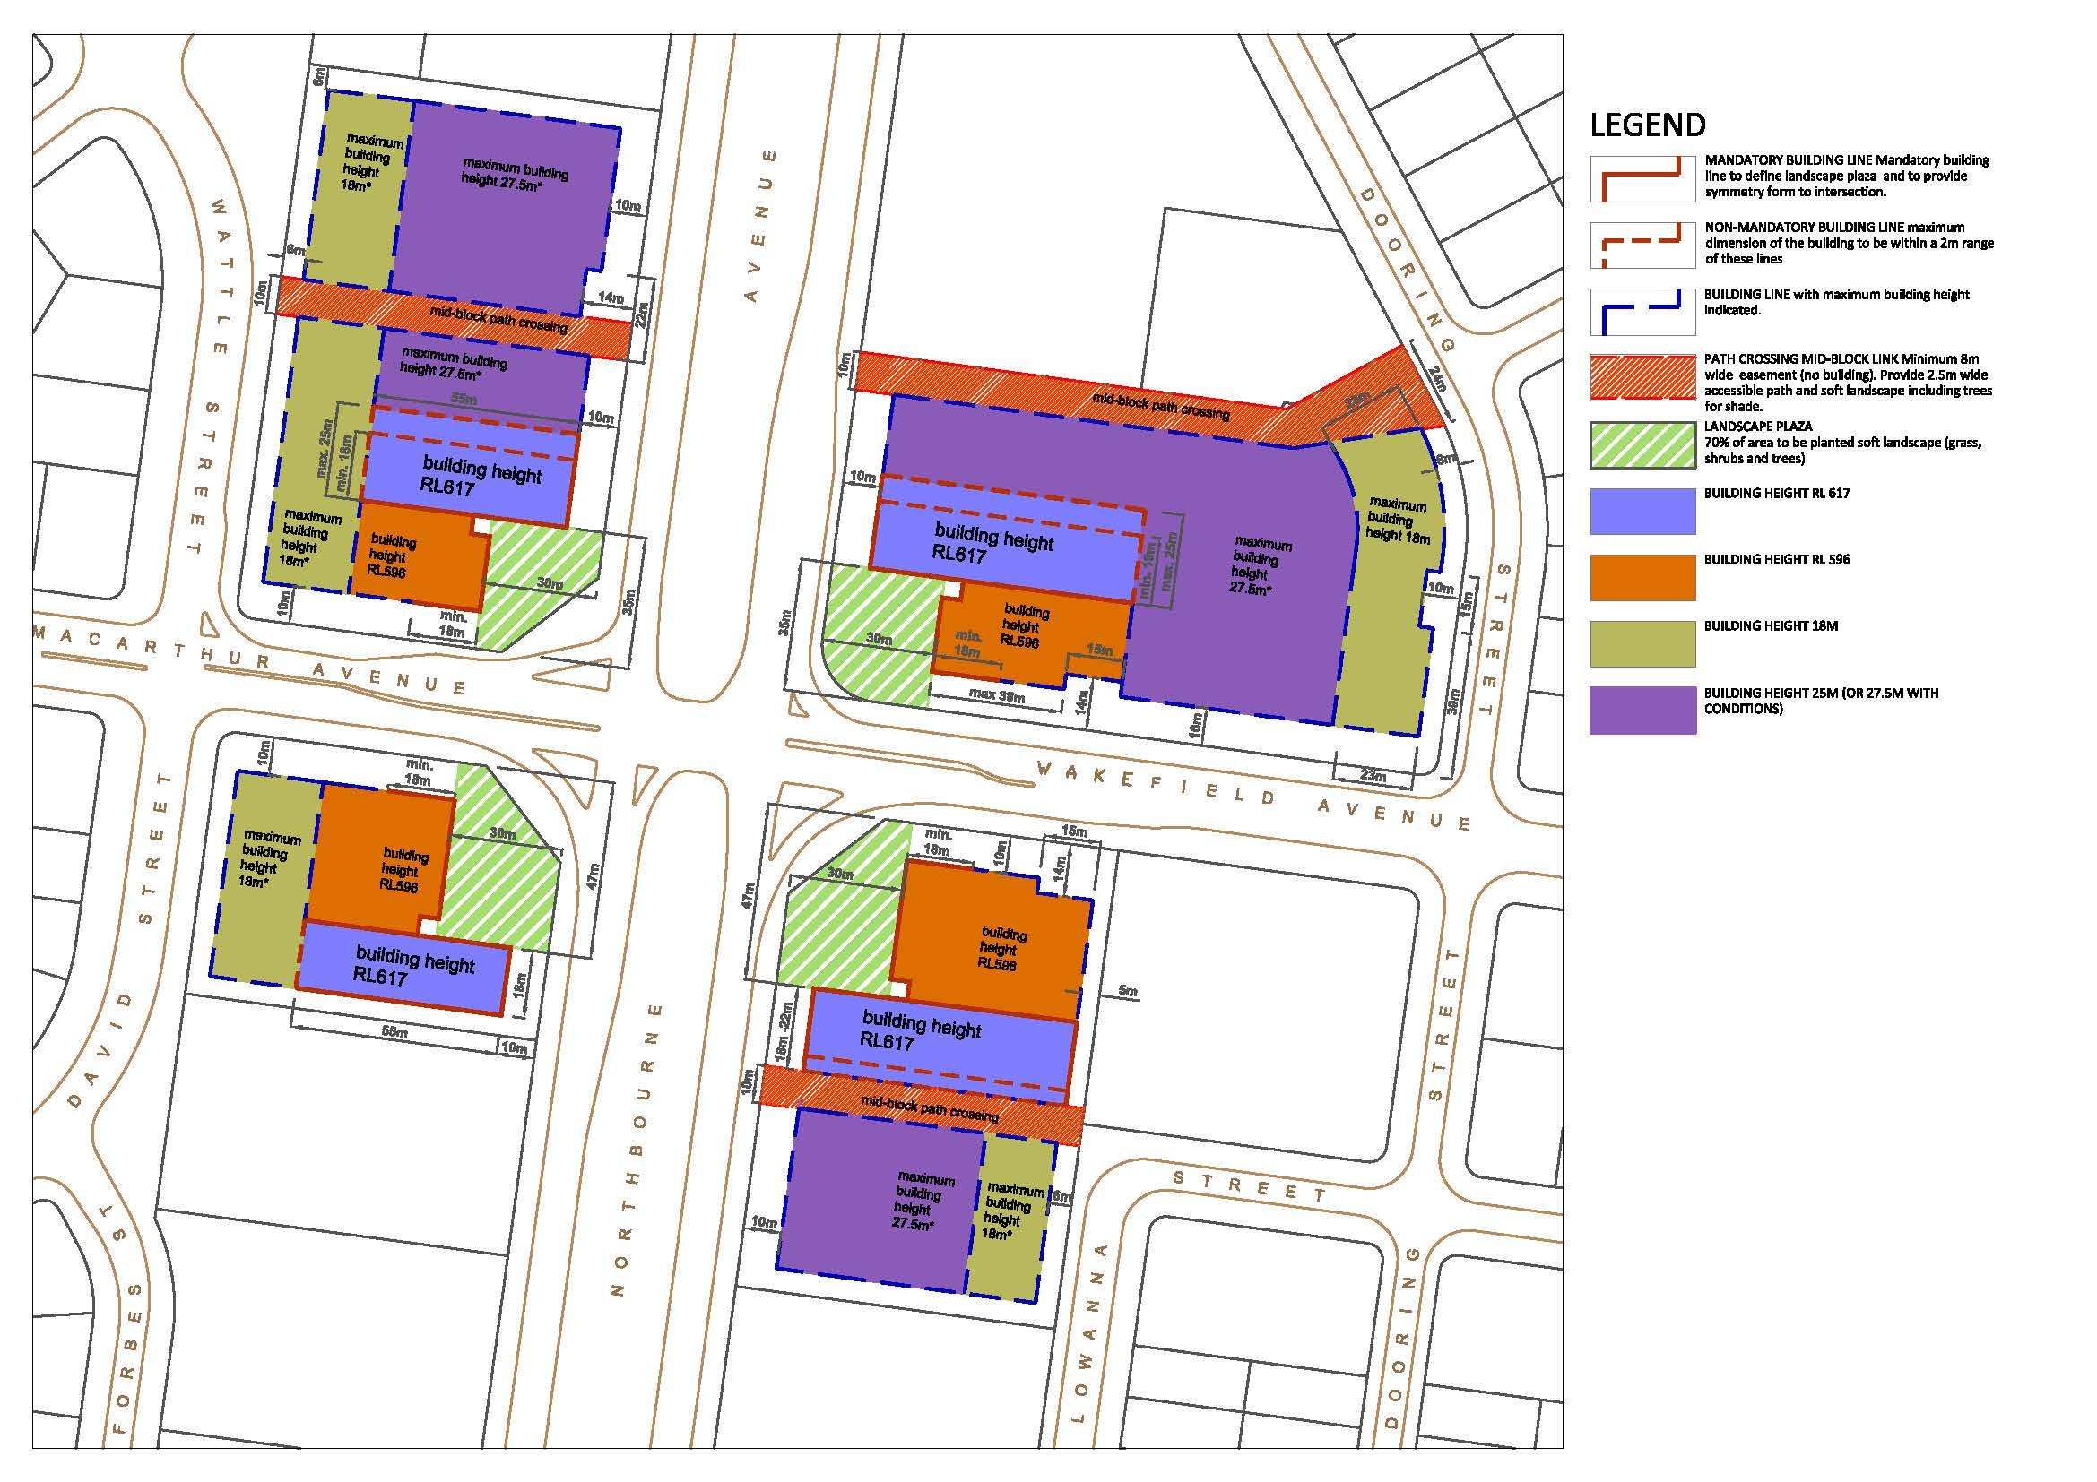

Figure 146: Development requirements, including permitted building heights, at the intersection of Northbourne Avenue with Macarthur/Wakefield Avenues

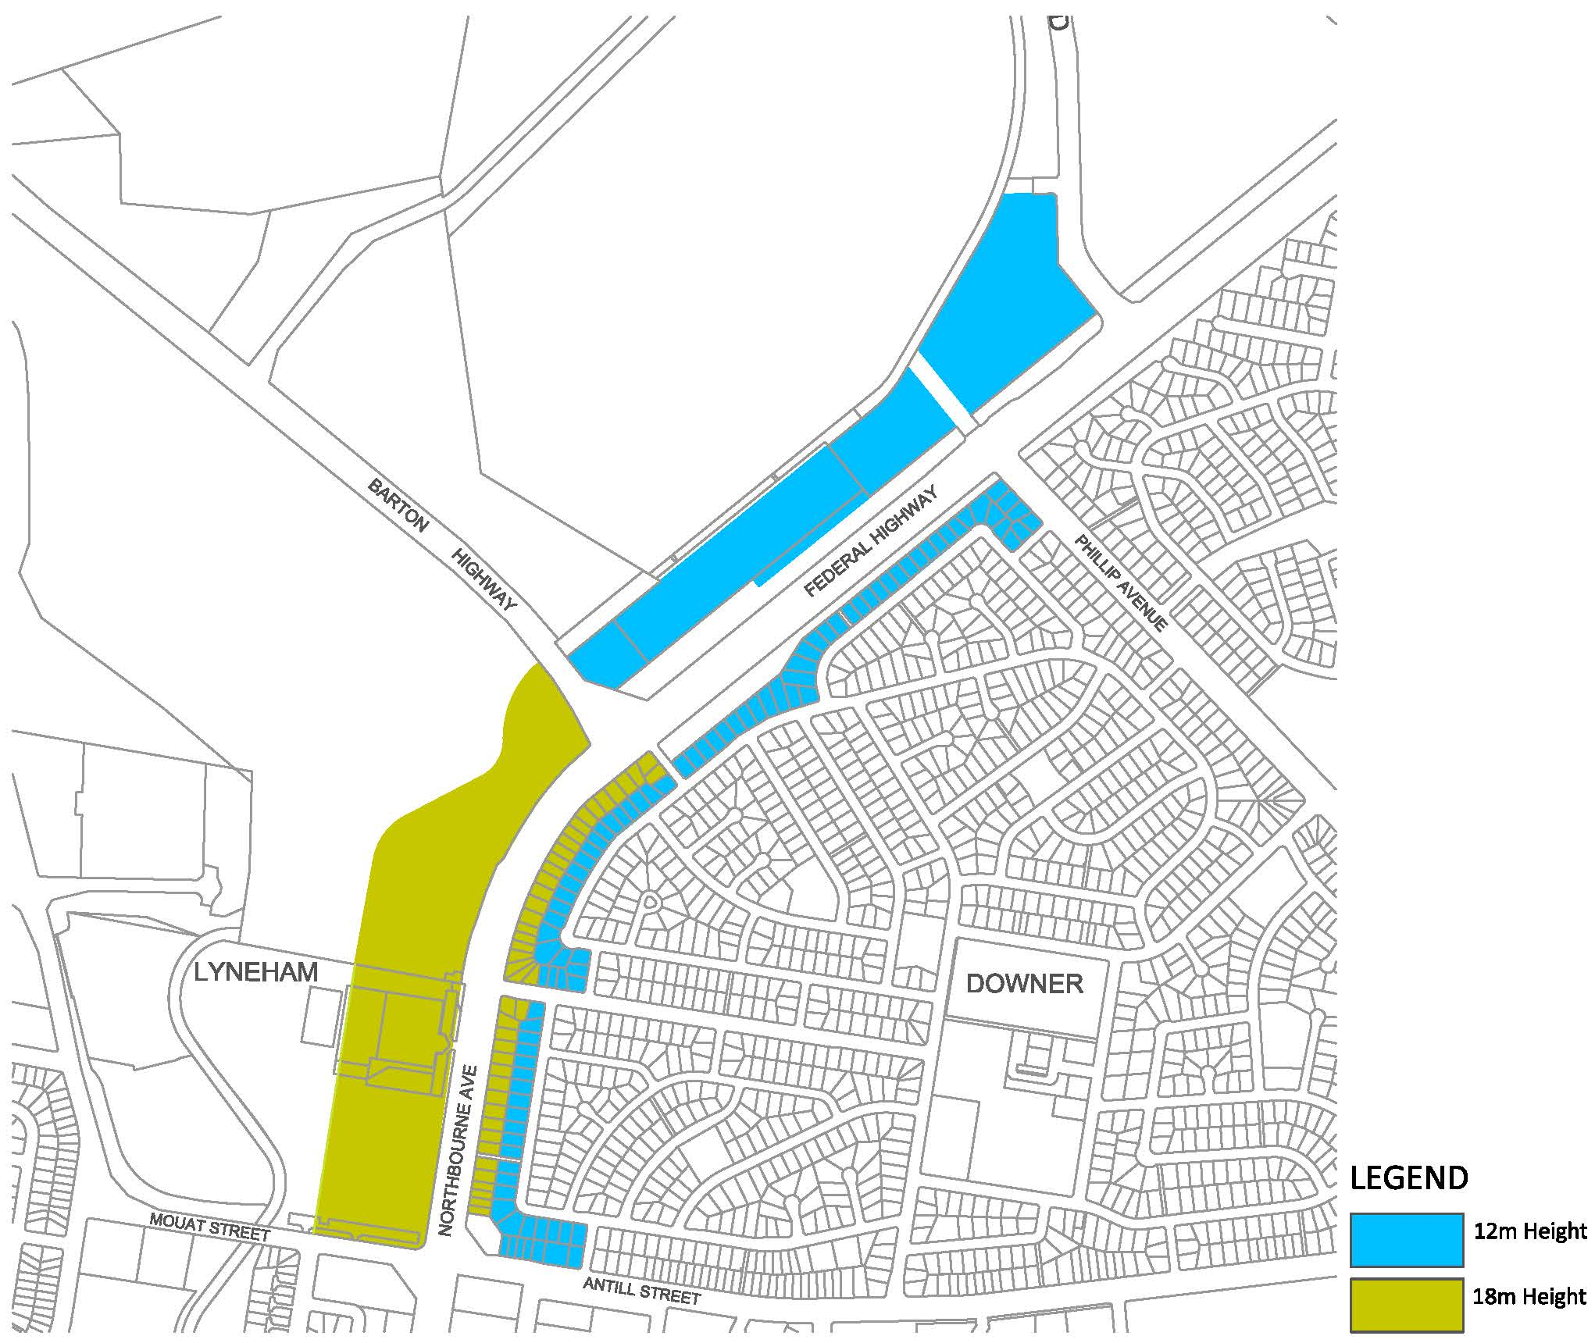

Figure 147: Permitted building heights from Antill/Mouat Streets Phillip Avenue and Flemington Road

#### Building setbacks

Northbourne Avenue

Buildings must be set back a minimum of 10 metres from the property boundary adjacent to Northbourne Avenue.

Basements and balconies must not extend into the setback area adjacent to Northbourne Avenue. Minor encroachment such as awnings or architectural details may be considered if the materials and design are such that the visual integrity of the building line is retained.

A composition of soft landscaping should be provided between the building line and property boundaries to Northbourne Avenue and major cross streets. Hard surfacing, other than for pathways and driveways, should be avoided. Parking and porte cochere vehicle drop off spaces are not permitted.

Rear and side setbacks must be in accordance with the relevant provisions of the Territory Plan.

Federal Highway

Minimum required building setbacks to the Federal Highway are to be in accordance with Figures 148 and 149, and as follows:

* Between Antill/Mouat Streets and the Barton Highway/Panton Street – 45 metres from the centreline of the Federal Highway.
* Between the Barton Highway/Panton Street and Flemington Road/Phillip Avenue – 70 metres from the centreline of the Federal Highway.
* On the northern side of the Federal Highway between Flemington Road and the ACT/NSW border – 30 metres from the Federal Highway road reservation.
* On the southern side of the Federal Highway between Phillip Avenue and Stirling Avenue – 6 metres.
* On the southern side of the Federal Highway between Stirling Avenue and the eastern boundary of Block 18 Section 75 Watson – 15 metres.
* On the southern side of the Federal Highway between the eastern boundary of Block 18 Section 75 Watson and the ACT/NSW border – 30 metres.

Rear and side setbacks must be in accordance with the relevant provisions of the Territory Plan.

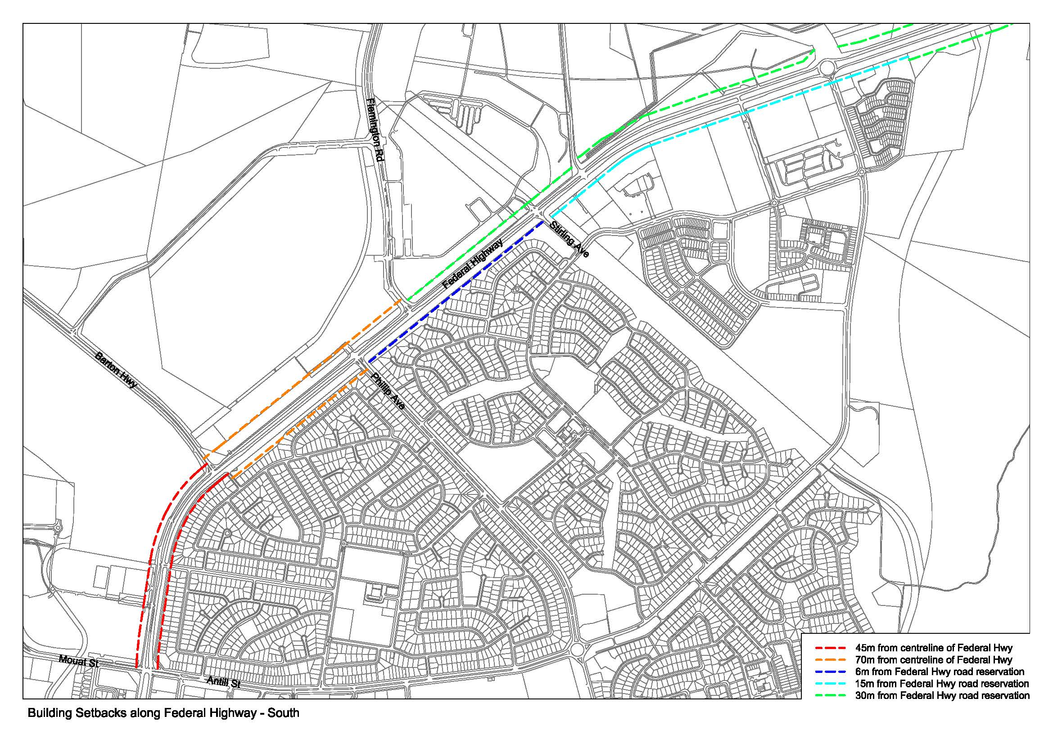

Figure 148: Required building setbacks for Federal Highway (south)

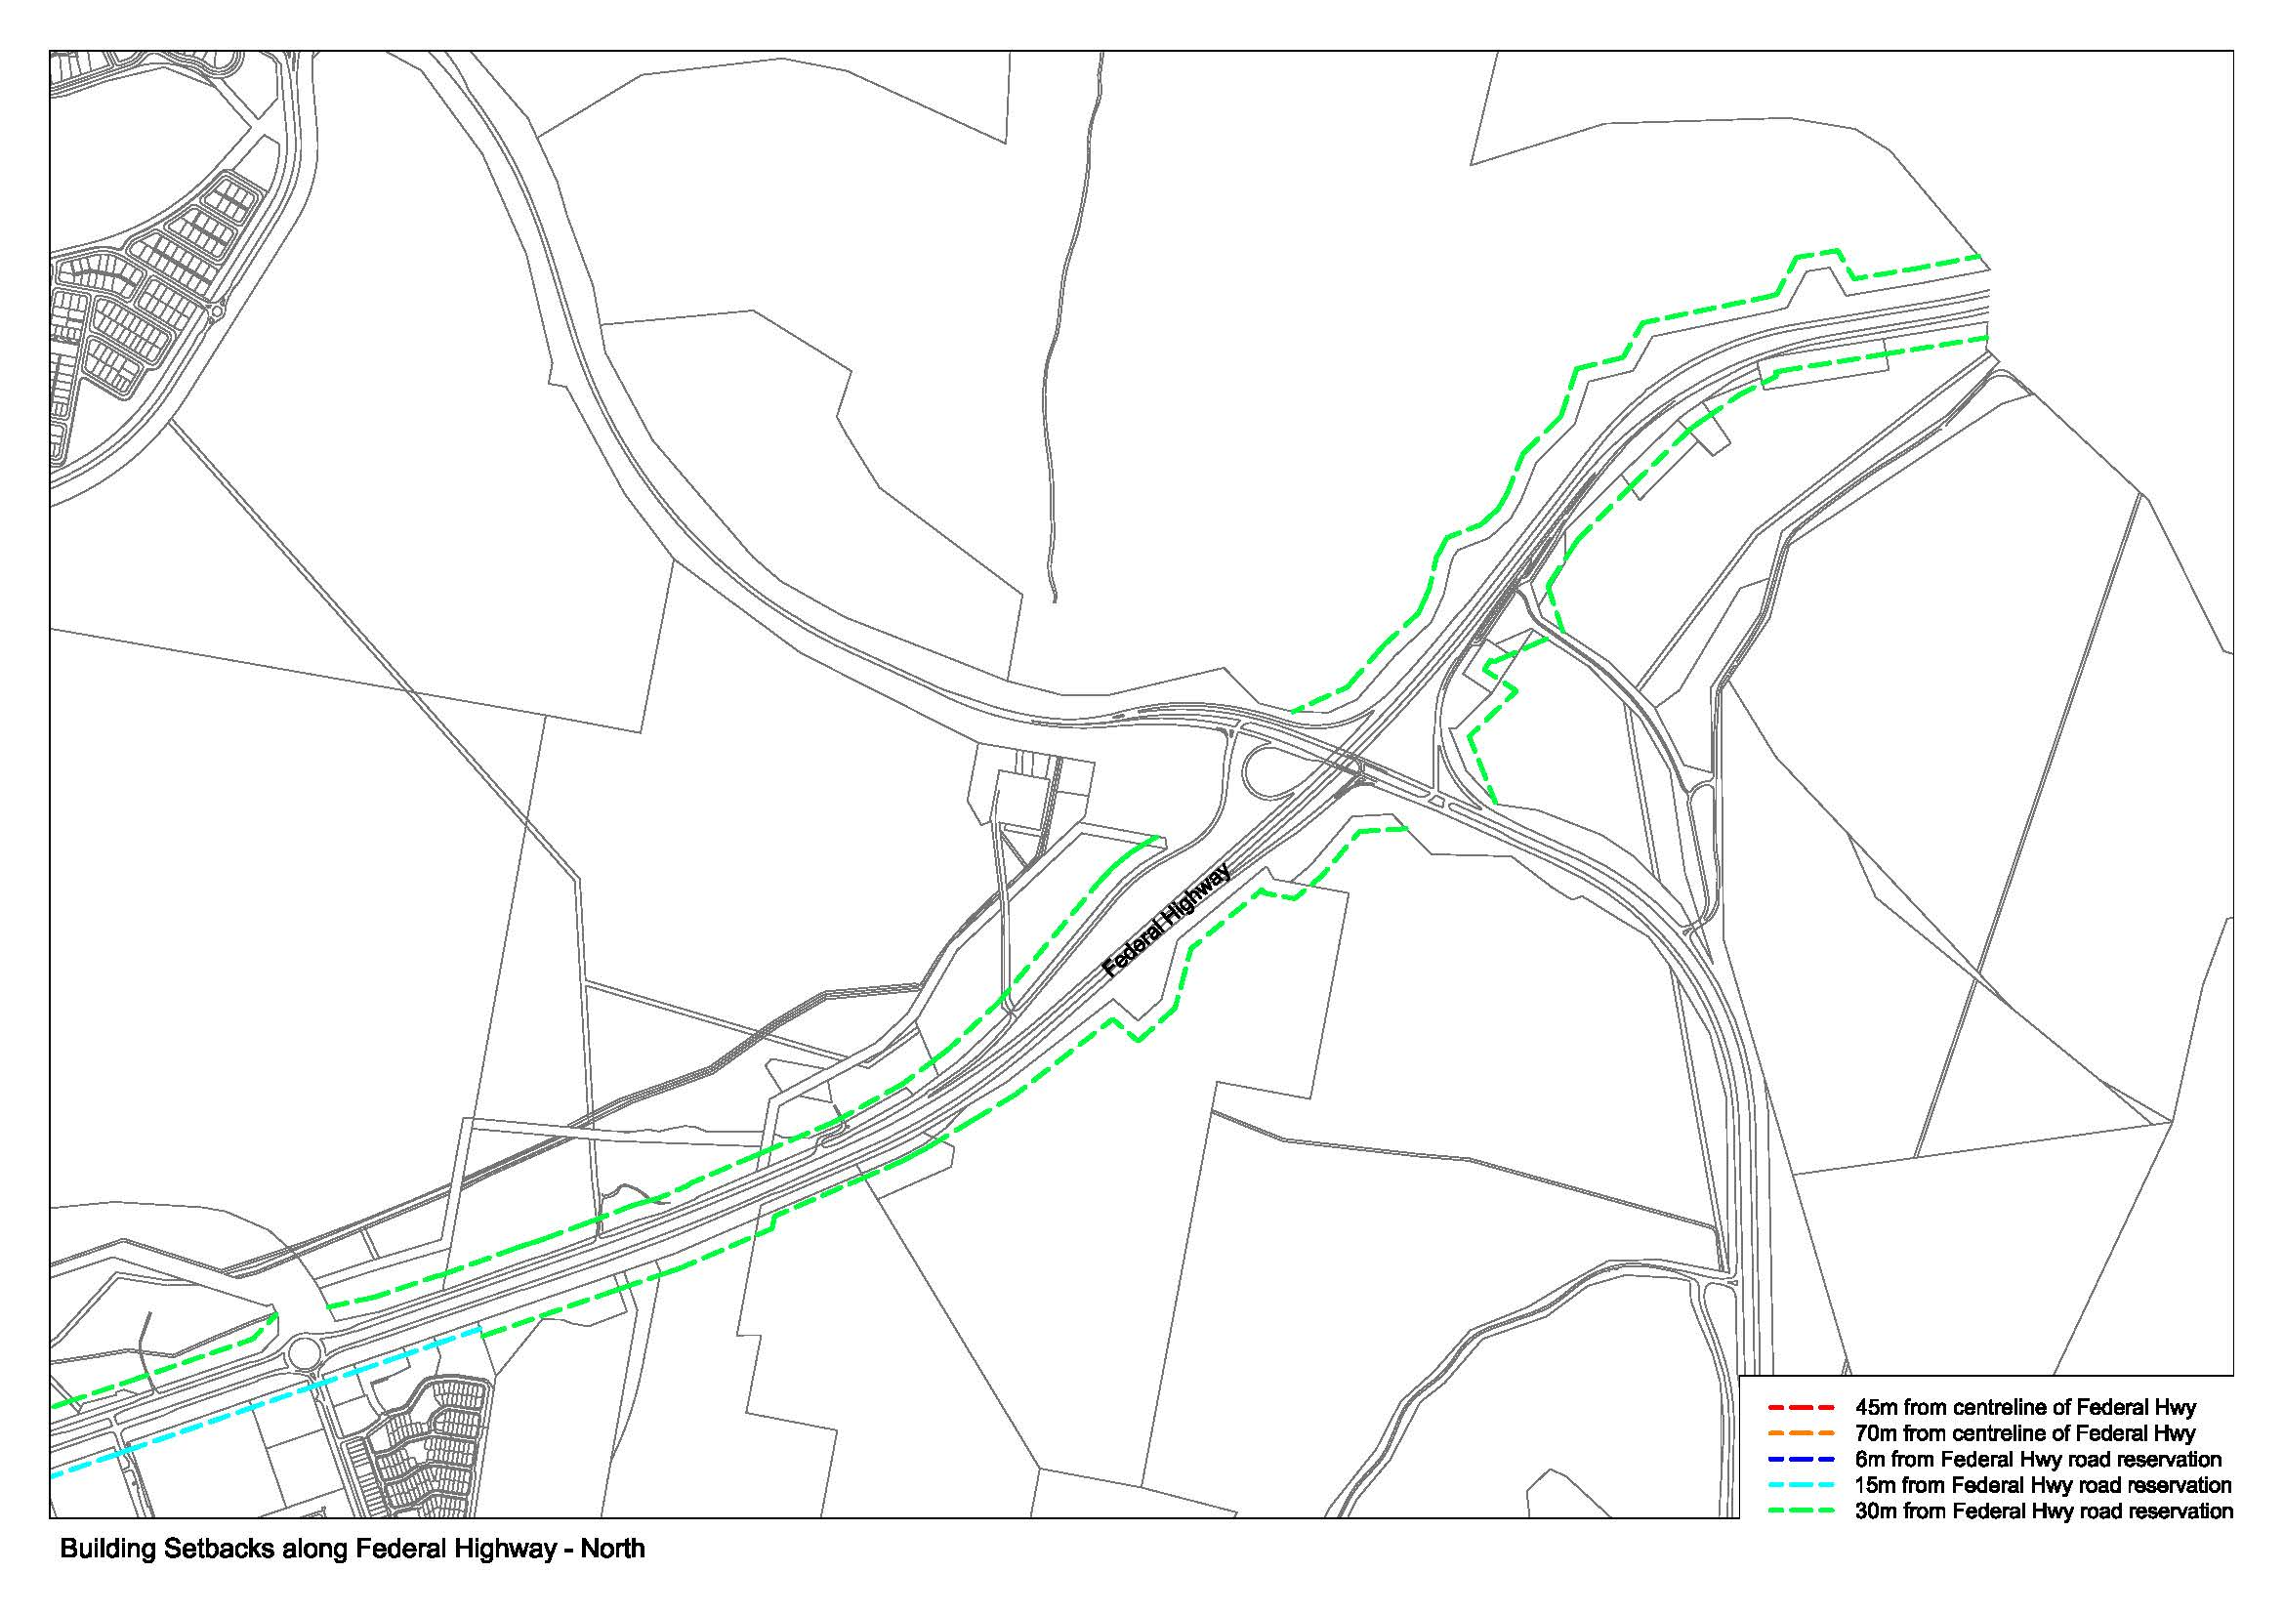

Figure 149: Required building setback for Federal Highway (north)

#### Building separation

Minimum separation distances for buildings are:

|  |  |  |  |
| --- | --- | --- | --- |
| Building height | Between habitable rooms/balconies | Between habitable and non-habitable rooms | Between non-habitable rooms |
| Up to 4 storeys | 15m | 10m | 6m |
| Up to 8 storeys | 20m | 15m | 10m |
| 9+ storeys | 25m | 20m | 15m |

Where a building abuts a lower density zone, building setbacks to the boundary of sites zoned for lower density should be increased by three metres.

Greater building setbacks may be required by the approving authority where increased building separation may achieve better amenity outcomes.

Building separation is measured from the outer face of building envelopes which includes balconies. When applying building separation distances to buildings on adjoining sites, apply half the minimum separation distance measured to the boundary where possible.

Note:

Minimum building separation distances apply to buildings within development sites, between apartments and non-residential uses, and to buildings on adjacent sites with a shared boundary.

#### Length of buildings

Long buildings that limit permeability, block views, and disrupt a pedestrian-scaled neighbourhood system should be avoided.

New buildings are limited to a maximum length of 55 metres. Longer buildings may be permitted at lower building levels where strong design justifications is provided, such as provision of continuous, active street frontages. Where this is the case, pedestrian mid-block links between 5 and 10 metres wide must be provided at least once every 55 metres through the built form. Longer buildings may also be permitted at the intersection of Northbourne Avenue with Macarthur/Wakefield Avenues, where the buildings run perpendicular to the Northbourne Avenue and where building design meets all relevant provisions regarding façade design, articulation, and roof design.

### Building design and architecture

#### Building façades

Building façades should relate to key datum lines of adjacent buildings through upper level setbacks, parapets, cornices, awnings or colonnade heights.

Façade design is to include the use of articulation and modulation to clearly express the organisational or structural grid of the buildings, and to break up the mass of longer buildings. Blank walls are discouraged.

A balance of light and shadow on the façade is to be created throughout the day through the use of balconies, deeper window reveals, integrated shading, rebates, and expression of structural elements.

Façade design should give important corner visual prominence through a change in articulation, materials or colour, roof expression or changes in height.

Façade materials must be of high quality. A use of robust, low maintenance materials in the higher parts of a building, and natural, tactile and visually interesting materials at the lower levels should be used. Pre-finished metal building materials visible from Northbourne Avenue or the Federal Highway are not permitted.

Building entries must be clearly defined and identifiable from the street.

*Balconies and balustrades*

Balconies must be incorporated into the design of all residential dwellings.

Minimum balcony areas are:

* Studio apartments – 8m² with a minimum dimension of 2 metres
* 1 bedroom apartments – 10m² with a minimum dimension of 2.5 metres
* 2 bedroom apartments – 12m² with a minimum dimension of 2.5 metres
* 3+ bedroom apartments – 24m² with a minimum dimension of 2.5 metres.

For apartments at ground level or on a podium or similar structure, a private open space must be provided instead of a balcony, of the following minimum size:

* Studio apartments – 18m² with a minimum dimension of 4 metres
* 1 bedroom apartments – 24m² with a minimum dimension of 4 metres
* 2 bedroom apartments – 24m² with a minimum dimension of 4 metres
* 3+ bedroom apartments – 36m² with a minimum dimension of 6 metres

Clothes drying, storage units, or plant and equipment (including air conditioning plant) are not permitted on balconies.

Balconies must be designed to allow views and passive surveillance of the street while maintaining visual privacy and allowing for a range of uses on the balcony. Balconies must be designed in accordance with the following:

* Balustrades to balconies to 12 metres above ground floor level must be solid.
* Full width and full height glass balustrades are not permitted below 20 metres.
* 60% of balustrades of any apartment 12- 20 metres above ground floor level must be solid.

To maintain visual and acoustic privacy, partitions between adjacent balconies must be constructed of masonry. Operable screens, shutters, hoods and pergolas are encouraged to control sunlight and wind.

#### Roof design

The design of the roof should be integrated into the architecture of the building, use high quality materials, and provide a positive addition to the streetscape. Continuous, horizontal parapets extending the full length of the building are not permitted.

Service elements and roof top plant must be integrated into roof design and not be visible from public areas, including streets.

The design of roofs and parapets should be articulated and express the layout of the building.

Roof design should incorporate sustainability features to maximise solar access to internal building spaces during winter and provide shade during summer.

Communal open space areas and rooftop gardens may be considered. Fully enclosed structures on roof tops are not permitted. Structures such as pergolas must not occupy more than 10 per cent of the total roof area.

For sites between Panton Street/Barton Highway and ACT/NSW border, flat roofs or facades with wide fascias giving the impression of a flat roof are not permitted.

#### Ceiling heights

Ceiling heights should promote natural ventilation and daylight access to internal building spaces, and contribute to the flexibility of building use over the life of the building.

Northbourne Avenue

Minimum floor to ceiling heights within buildings adjacent to Northbourne Avenue shall be as follows:

Ground floor facing Northbourne Avenue (uses other than residential) – 6.0 metres (mezzanine permitted over 30% of ground floor)

Ground floor (residential) – 3.3 metres

Ground floor (other uses, including commercial/office use) – 3.6 metres

Residential (general) –

* 2.7 metres floor-to-ceiling minimum for all habitable rooms, and 2.4 metres for all non-habitable rooms.
* For two-storey units, 2.4 metres minimum for second storey if 50 percent or more of the apartment has 2.7 metre minimum ceiling heights.
* For two-storey units with a two-storey volume living space, 2.4 metre minimum ceiling heights.
* Attic spaces are permitted, with a 1.8 metre minimum wall height at edge of room with a 30 degree minimum ceiling slope.

Federal Highway

Ground floor (residential) – 3.3 metres

Ground floor (other uses, including commercial/office use) – 3.6 metres

Residential (general) –

* 2.7 metres floor-to-ceiling minimum for all habitable rooms, and 2.4 metres for all non-habitable rooms.
* For two-storey units, 2.4 metres minimum for second storey if 50 percent or more of the apartment has 2.7 metre minimum ceiling heights.
* For two-storey units with a two-storey void living space, 2.4 metre minimum ceiling heights.

Attic spaces are permitted, with a 1.8 metre minimum wall height at edge of room with a 30 degree minimum ceiling slope.

#### Residential apartment design

The layout of rooms within an apartment must be functional, well organised and provide a high standard of amenity. Dwellings are required to have the following minimum internal areas:

|  |  |
| --- | --- |
| Dwelling type | Minimum internal area |
| Studio | 40m² |
| 1 bedroom | 60m² |
| 2 bedroom | 80m² |
| 3 bedroom | 110m² |

The minimum internal areas include only one bathroom. Additional bathrooms increase the minimum internal area by 5m² each. Additional bedrooms increase the minimum internal area by 12m² each.

Habitable room depths are limited to a maximum of 2.5 x the ceiling height. In open plan layouts (where the living, dining and kitchen are combined) the maximum habitable room depth is 8 metres from a window.

The following design criteria must be achieved to ensure that dwelling layouts accommodate a variety of household activities and needs:

1. Master bedrooms must have a minimum area of 10m² and other bedrooms 9m² (excluding wardrobe space).
2. Bedrooms must have a minimum dimension of 3m (excluding wardrobe space).
3. Living rooms or combined living/dining rooms have a minimum width of:
   1. 3.6 for studio and 1 bedroom apartments
   2. 4m for 2 or more bedroom apartments.
4. The width of cross-over or cross-through dwellings are at least 4m internally to avoid deep narrow dwelling layouts.

#### Common circulation spaces

The maximum number of dwellings off a circulation core on a single level should be no more than eight. Where this is not achievable, a high level of amenity for common lobbies and corridors should be demonstrated through the provision of access to ample daylight and natural ventilation, common areas for seating and gathering, and generous corridors with greater than minimum ceiling heights.

For buildings of ten storeys and over, the maximum number of dwellings sharing a single lift is 40.

Corridors longer than 12 metres from the lift core should be articulated, for example by a series of foyer areas with windows and spaces for seating, and wider areas at apartment entry doors and varied ceiling heights.

Primary living room or bedroom windows must not open directly onto common circulation spaces, whether open or closed.

#### Environmental performance

Energy efficiency

Development should incorporate passive solar design to optimise heat storage in winter and reduce heat transfer in summer. Potential design options include the use of smart glass or other technologies (particularly on north and west elevations), maximising thermal mass in the floors and walls of north facing rooms, overhangs and shading devices such as awnings, blinds and screens.

Operable screening such as louvres, sliding, folding or retractable elements should be designed to provide shade and protection from natural elements. Operable screening elements must be integrated with building design.

Residential use

To optimise direct sunlight to habitable rooms and balconies, design features such as dual aspect apartments, shallow apartment layouts, two storey and mezzanine level apartments and bay windows should be used. Building design must achieve the following:

* Living rooms and private open spaces of at least 70% of apartments in a building must receive a minimum of 3 hours direct sunlight between 9am and 3pm on the winter solstice (21 June).
* A maximum of 15% of apartments in a building receive no direct sunlight between 9am and 3pm on the winter solstice (21 June).

All habitable rooms must have an operable window in an external wall with a total minimum glass area of not less than 15% of the floor area of the room. Courtyards, skylights and high level windows (with sills above 1500mm) should only be used as a secondary light source in habitable rooms.

A ‘snorkel’ arrangement may be provided for bedrooms only (refer Figure 150). Where this arrangement is proposed, a window may provide daylight to a bedroom from a smaller secondary area within the bedroom where the window is clear to the sky. The secondary area should be a minimum width of 1.2 metres, and a maximum depth of 1.5 times the width, measured from the external surface of the window.

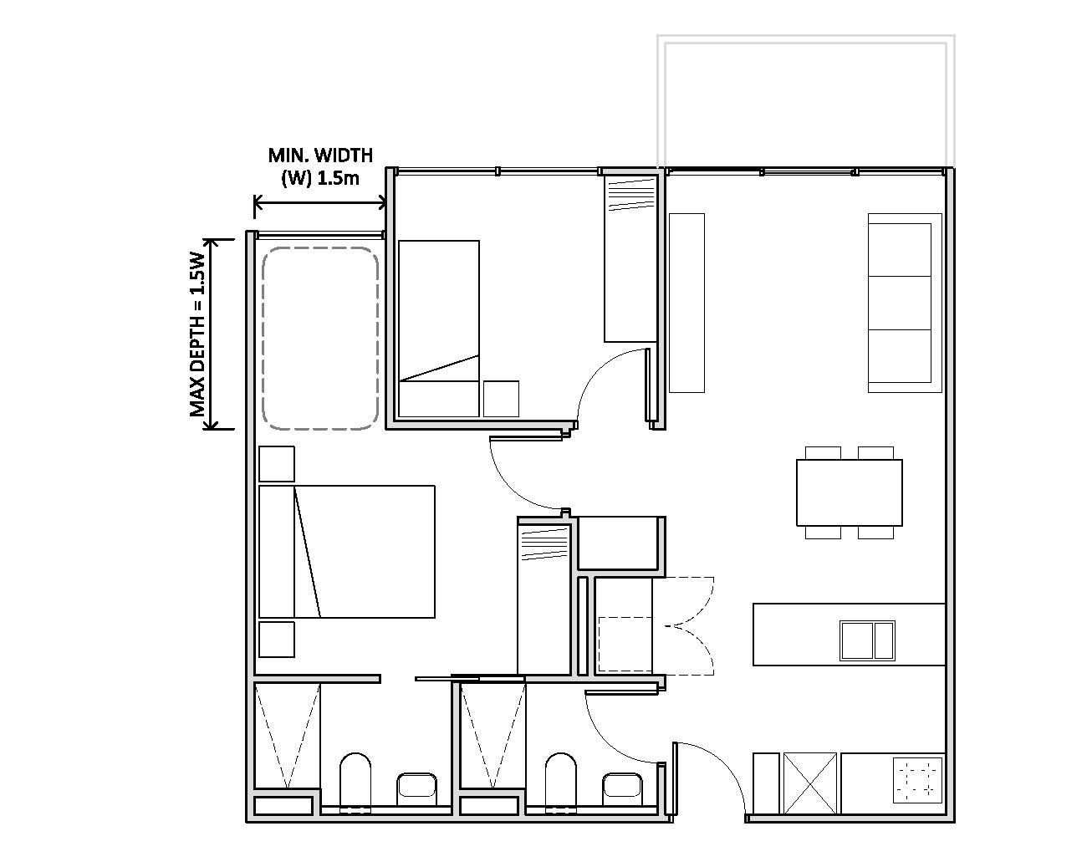

Figure 150: Indicative apartment layout with bedroom snorkel arrangement

All habitable rooms should be naturally ventilated. Building design should demonstrate consideration of the building’s orientation to maximise capture and use of prevailing breezes, depths of habitable rooms, openable windows and the use of awnings and louvres to funnel breezes. Lights wells must be the primary air source for habitable rooms.

The number of apartments with natural cross ventilation is maximised to create a comfortable indoor environment for residents. At least 60% of apartments should be naturally cross ventilated in the first nine storeys of a building. Apartments at ten storeys or greater are deemed to be cross ventilated only if balcony enclosure allows adequate natural ventilation and cannot be fully enclosed.

### Street frontage

Finished ground floor levels set below the adjacent finished pavement levels on Northbourne Avenue and the Federal Highway are not permitted. The fall from the building entrance to the kerb must generally be no greater than 2%.

Where ground floor residential development is proposed, a vertical separation above the finished ground level and adjacent verge and setback area up to 450mm is permitted to assist in providing privacy for floor residences.

Where commercial uses are located on ground floors of buildings, buildings must be designed to ensure a direct connection to the adjacent verge and setback area to ensure street continuity.

Service areas must be integrated within the building design to avoid impacting the public domain. Basement car parks should not be visible from the street.

### Landscape

#### Landscape character

Landscape design for development along the Federal Highway and Northbourne Avenue corridor is a fundamental character feature of the gateway into the city centre. It should unite development with the existing landscape character of Canberra, soften the impact of larger building form and provide visual relief to the urban condition, consistent with Canberra’s status as the bush capital.

New development must provide substantial tree and understorey planting, supported by functional , safe and attractive private and public areas of open space. Development must continue to deliver Canberra as a city in a landscape.

The spaces between buildings must be landscaped to a high quality and promote green links between the private and public domain.

Landscape spaces must be designed to clearly differentiate between areas intended for public and private use, maximising the functionality of both. Landscaped areas must be designed for maximise user comfort and safety.

Planting within setback areas should consist primarily of trees, as opposed to shrubs or other low vegetation. A minimum of 30 per cent of new plantings within setback areas should be capable of achieving at least 15 metres in height.

All new developments must renew the adjacent road verge in accordance with the principles outlined in this section.

Mature trees should be retained to the maximum extent practicable and integrated into landscape design. Where existing trees must be removed, they must be compensated for by planting elsewhere on site.

All Landscaping within development sites must complement the landscape design themes evident in the corridor:

Border to Stirling Avenue

Development must meet the requirements for the identified landscape realms and themes for the Federal Highway at section 4.15.4 of the National Capital Plan.

South of Stirling Avenue

The scale of landscape must respond primarily to the height of adjacent buildings, ensuring the landscape is the dominant element. Built form should be screened through the use of plant material.

Between Stirling Avenue and Antill/Mouat Street, an ‘informal park boulevard’ should be established. This ‘informal park boulevard’ should primarily comprise tree species endemic to the Canberra region and capable of reaching 20 metres in height. Species such as Eucalyptus melliodora, Eucalyptus melliodora and Eucalyptus polyanthemos are considered suitable. Spacing between trees should be no greater than 15 metre centres.

South of Antill/Mouat Streets

A ‘formal landscape avenue’ containing consistent street tree planting within the verge and extending into the setback area.

Landscape design may reflect the formality of Northbourne Avenue, and include rows of trees, regulatory in planting, and formal hedging.

Landscape design and planting should respond to Canberra’s blend of endemic and introduced species, reinforcing the ‘bush capital’. Plant species should be chosen for their effectiveness and adaptability to Canberra’s climate to reduce heat islands and to maximise shade.

#### Deep soil zones

A planting zone, no less than five metres wide, should be provided within the front setback areas and be retained for deep soil planting.

Front setback areas should be retained for deep soil planting.

A minimum deep soil zone dimension of five metres should be applied where located on site.

Deep soil zones should be located to retain existing significant trees and to allow for the development of healthy root systems, providing anchorage and stability for mature trees. Landscape and building design must demonstrate:

* the consolidation of basement and sub-basement car parks beneath building footprints
* adequate clearance around trees to ensure long term health
* co-location with other deep soil areas on adjacent sites to create larger contiguous areas of deep soil.

### Access and parking

Northbourne Avenue

Vehicle access, including verge crossings and driveways, to sites shall be located and designed to ensure pedestrian priority. The design of vehicle access arrangements to sites fronting Northbourne Avenue should ensure that pedestrian desire lines and footpaths are maximised, the width of the vehicle access way is minimised and its materials integrate with landscaping within the verge and setback.

Where possible, sites should share vehicle access via a shared space with adjoining properties, that extends from Northbourne Avenue to the rear street frontage. The space should be designed to prioritise pedestrian movement, contain high quality public realm treatments, including tree planting, footpaths and lighting that add visual interest.

Where a site cannot accommodate shared access arrangements, a maximum of one crossover per block is permitted. The crossover and driveway should be located as far as possible to a block boundary rather than towards the centre of the block.

To minimise potential conflicts, pedestrian and vehicle access to sites should be clearly separated and distinguishable. This may include changes in surface materials, level changes, or the use of landscaping for separation.

Car parking should be provided in basements. On-grade parking is discouraged and will only be permitted if the following criteria are met:

* parking is located to the rear of the site away from Northbourne Avenue and major cross streets
* cars are screened from view to the maximum extent possible of streets, buildings, communal and private open space areas
* parking is incorporated into the landscape design of the site, by extending planting and materials into car parking space
* light coloured paving materials or permeable paving systems are used and shade trees are planted between every 4-5 parking spaces to reduce increased surface temperatures from large areas of paving.

Car park entries should be located away from Northbourne Avenue.

A traffic and parking assessment should accompany development proposals for any site, and this will be determined in consultation with the approving authority.

Federal Highway

On- site car parking is to be in accordance with the ACT Parking and Vehicular Access General Code of the Territory Plan.

The visual impact of large car parking areas must be minimised through adequate screening and landscape treatment that appropriately considers view lines and safety.

Careful consideration should be given to the access, internal circulation and parking of service and heavy goods vehicles within the area.

A traffic and parking assessment should accompany development proposals for any site, and this will be determined in consultation with the approving authority.

### Lighting

All outdoor lighting, including security and car park lighting, must be designed and sited to minimise light pollution. All outdoor lighting (including lighting fixed to structures) must use full cut-off light fittings. Any uplighting of buildings should be carefully designed to keep night time overspill and glare to a minimum.

Specialty lighting should be used to highlight any ACT border marker.

### Signage

Northbourne Avenue

Careful consideration should be given to the integration of signs with building design and landscaping to ensure they do not detract from the Northbourne Avenue frontage. Any signage not affixed to a building must be within a landscape setting.

Signage across a site should be designed in accordance with a cohesive and coordinated theme, and respond to the scale, proportion and detailing of the development.

To minimise visual clutter, individual commercial tenancies should have no more than one sign fronting Northbourne Avenue. For residential development, a single wall sign is permitted, of no more than 10% in size of the façade on which it is located. Larger developments may include legible and discrete way finding signage.

Permitted road signs are those that could reasonably be expected along a main thoroughfare, such as directional signage and street signs, and that are required by relevant traffic authorities. No commercial advertising is permitted on road signs.

Changeable message signs, animated or flashing signs, and third party advertising signs are not permitted on building facades or roofs visible from, or within setback areas to, Northbourne Avenue.

Federal Highway

Careful consideration should be given to the integration of signs with building design and landscaping to ensure they do not detract from the Federal Highway frontage. Any signage not affixed to a building must be within a landscape setting.

Signage across a site should be designed in accordance with a cohesive and coordinated theme, and respond to the scale, proportion and detailing of the development.

All signs on buildings must be below the eaves or parapet capping of a building. A maximum of one wall sign visible from the Federal Highway road frontage will be permitted per building. The maximum permitted size of a wall sign is four square metres, or 10% of all space, whichever is the lesser.

Permitted road signs are those that could reasonably be expected along a main thoroughfare, such as directional signage and street signs, and that are required by relevant traffic authorities. No commercial advertising is permitted on road signs.

A single free standing pylon/column sign is permitted for the EPIC service station site (Block 4 Section 72 Lyneham and Block 429 Gunaghlin). No other free standing signage is permitted.

Temporary freestanding signage will be permitted where associated with events at EPIC. Such signage must be consistent with Territory signage policies or the Signs General Code of the National Capital Plan, depending on location.

### Fencing

Fencing along site frontages to Northbourne Avenue is not permitted.

Private open space for ground floor dwellings fronting Northbourne Avenue may be enclosed by fences or courtyard walls. Fences and courtyard walls to private open space fronting Northbourne Avenue must be:

* not higher than 1.8 metres above datum ground level, with solid components not higher than 1 metre
* constructed of high quality materials (pre-coloured metal, chain-link, barbed or razor wire is not permitted)
* integrated with landscaping.

Private open spaces must not extend more than four metres into the building setback area, and must not occupy more than 40 per cent of a building frontage.

For sites fronting the Federal Highway, fences are to be designed in a manner that is integral with the landscape design using high quality materials. The use of pre-coloured metal, chain-link, barbed or razor wire is not permitted and must not be visible from the Approach Route.

All fencing to site boundaries must not be bulky obtrusive.

### Design Review Panel

Redevelopment proposals must be considered by a joint National Capital Authority/ACT Government Design Review Panel prior to being approved by the Territory planning authority (where a proposal is on Territory Land) or supported by the National Capital Authority (where a proposal is on National Land).

1. **Add the following definitions, in alphabetical order, to Appendix B – General definitions:**

*Datum ground level*

Means the surface ground level as determined in a field survey authorised by a registered surveyor:

1. at the time of Operational Acceptance for subdivision; or
2. if a. is not available, provided no new earthworks have occurred; or
3. at the date of grant of the lease of the block;

whichever is the earliest.

Where a., b. or c. is not available, datum ground level is the best estimate of the surface ground level determined in a field survey considering the levels of the immediate surrounding area and authorised by a registered surveyor.

*Deep soil zone*

Means an area of soil within a development that is unimpeded by buildings or structures above and below ground, and which has sufficient dimensions to allow for the growth of healthy trees. Deep soil zones exclude basement car parks, services, swimming pools, tennis courts and impervious surfaces including car parks, driveways and roof areas.

*Habitable (including habitable room)*

Means a room within a dwelling capable of being lawfully used for the normal domestic activities of living, sleeping, cooking or eating, and –

1. includes a bedroom, study, living room, family room, kitchen, dining room, home theatre, rumpus room; but
2. does not include a bathroom, laundry, utility room, hallway, garage or other spaces of a specialised nature occupied either frequently or for extended periods.
3. **Amend the National Capital Plan to recognise consequential changes to page numbers, figure numbers and text references, and contents page.**